**Cover Page**



Date : 05-04-2021

This is to certify that Mr. Sourav Agrawal, Mr. Sahil Mansuri, Mr. Divyansh Jain from the Department of Computer Sciences , St. Xavier’s College (Autonomous) of BCA Semester-VI have successfully completed their project work as a trainee for the current semester for the academic year 2020-2021 , for the project titled “Online Food Ordering System”.

As part of the project, in the current semester they have completed following tasks under our company guidance:

* GUI Design
* Database Design
* Coding
* Report Generation

During the project work they were found sincere and cooperative. We admire their enthusiasm and involvement in the project.

Jugal Prajapati

Project Manager

**College Certificate**

**Acknowledgement**

Any project, simple or complex is successful largely due to the collective and individual efforts of a number of people who have given their valuable time and advice or lent a helping hand whenever necessary. It has been privilege to meet new people and have new experience and to learn from it all. We sincerely appreciate the motivation, support and inspiration given by all those people whose guidance has been essential and helpful in making this project a success. First and the foremost we would like to thank Dr. (Fr.)Johnson Mundupuzhakal Vice Principal(SF Courses) for giving us this opportunity to learn and provide us with facilities to complete the project. We concern ourselves lucky to have been exposed to the world of Artificial Intelligence.

We, Divyansh Jain, Sahil Mansuri and Sourav Agrawal, the students of St. Xavier’s College (Autonomous), are extremely grateful to “Aarnik Technology” for confidently entrusting us with the responsibility of the development and partial completion of the project “Online Food Ordering System” and convey our gratitude for the generous assistance and cooperation, that we received from Mr Jugal Prajapati our External Guide for making sure that the right resources were available to us at the right time and for providing his valuable insights and guidance.

We am sincerely thankful to our Internal Guide, Ms. Manali Bhrambhatt for her constant help, stimulating suggestions and encouragement helped us in completing various phases of our project.

We would also like to heartily thank all the faculty members of Department of Computer Sciences, St. Xavier’s College (Autonomous) for their timely advice and guidance without which this project would not have been possible.

Last but not the least, we also place our deep sense of gratitude to our family members and our friends who have been a constant source of inspiration and motivation during the completion of this project work so far.

**INDEX**

**SR. NO.**  **TOPICS**  **Page No.**

**1.SCREEN LAYOUTS**....................................................................................................6-45

1.1 ADMIN LAYOUTS..........................................................................................06

1.2 RESTAURANT LAYOUTS.............................................................................13

1.3 USER LAYOUTS.............................................................................................23

**2. REPORT LAYOUTS** ……………………………………………………………....46-56

2.1 REPORT FOR PAYMENTS……………………………………………........46

2.2 REPORT FOR DELIVERY………………………………………………….48

2.3 REPORT FOR FEEDBACK………………………………………………....50

2.4 REPORT FOR FOOD ITEMS…………………………………………….....53

2.5 REPORT FOR ORDERS…………………………………………………….55

**3. CONCLUSION**.................................................................................................................57

**4. BIBLIOGRAPHY**………………………………………………………………………58

**SR. NO. 1 SCREEN LAYOUTS**

**1.1 ADMIN LAYOUTS**

1. **Login Screen:**

**DESCRIPTION:**

* + The user needs to fill both username and password. Both fields are mandatory.

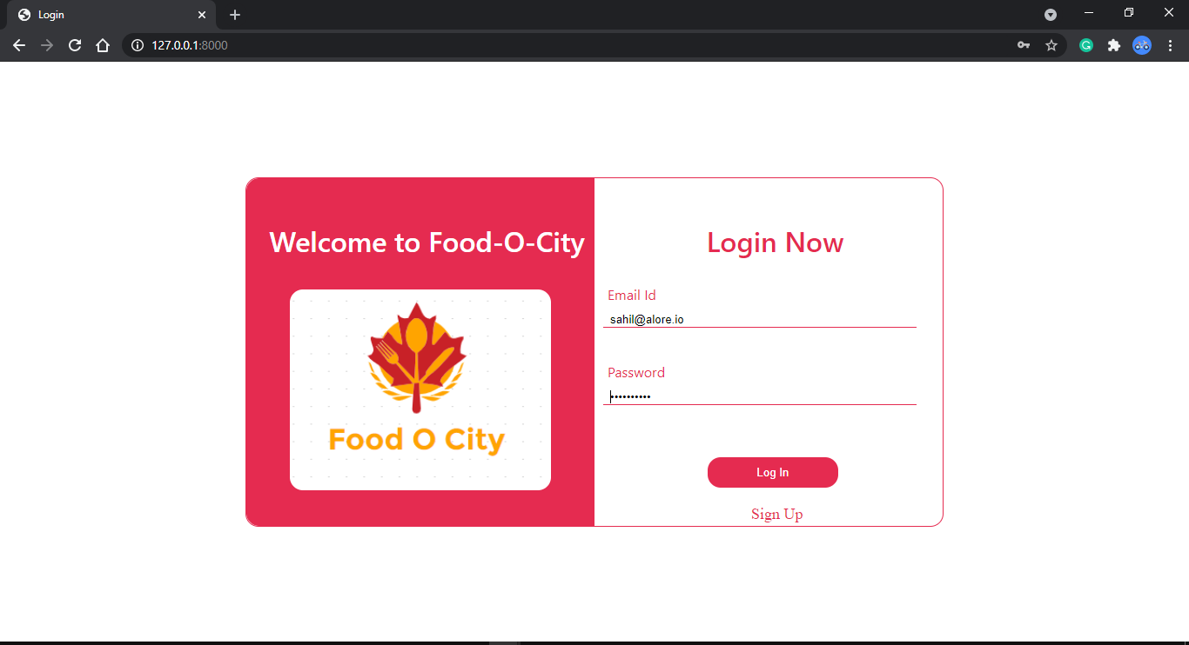

**SR. NO. 1 SCREEN LAYOUTS**

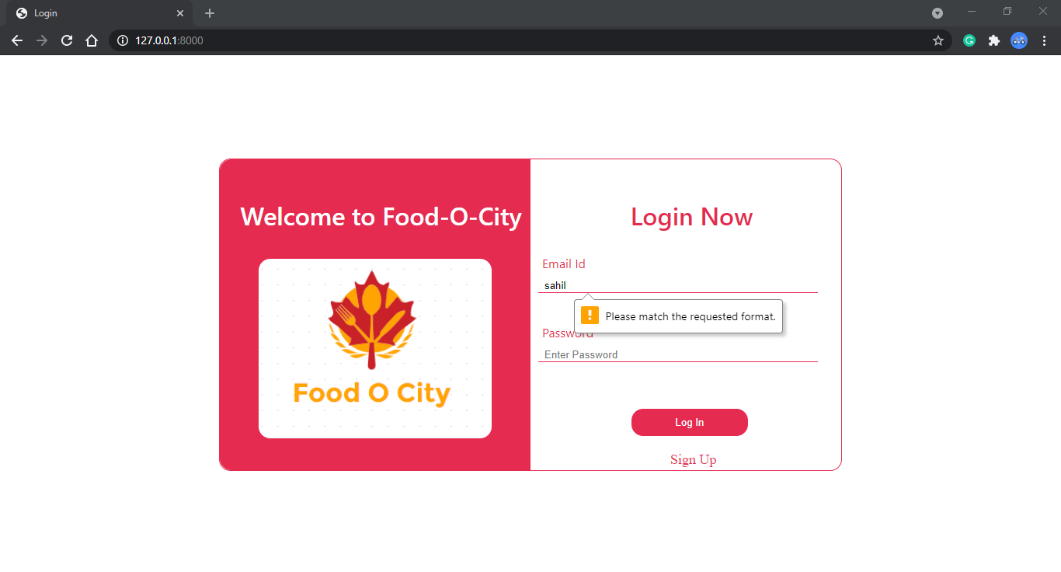

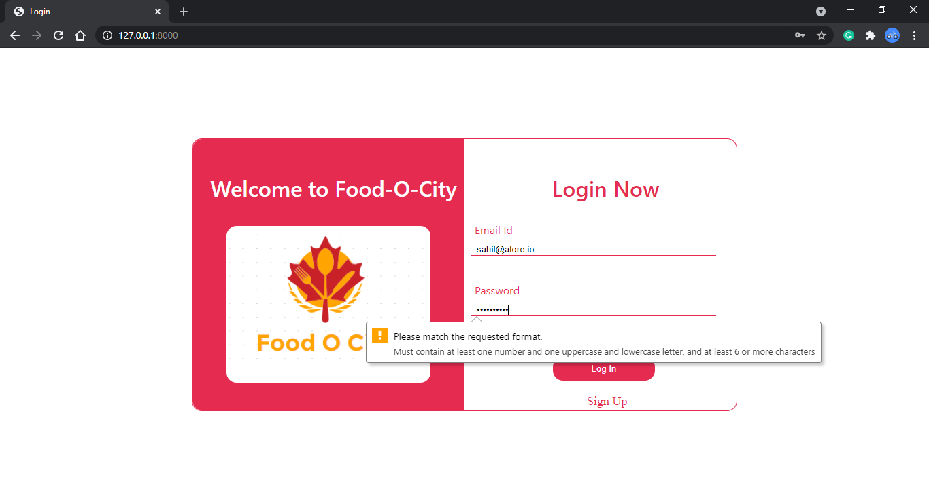

**SR. NO. 1 SCREEN LAYOUTS**

1. **Dashboard:**

**DESCRIPTION**:

* + When the admin enters the correct username and password, he will be navigated to dashboard.

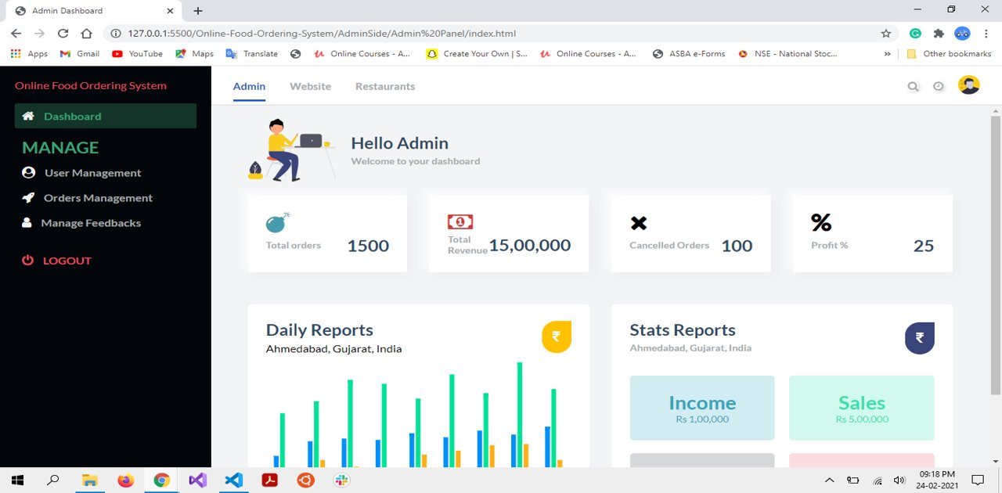

**SR. NO. 1 SCREEN LAYOUTS**

1. **User Management Screen:**

**DESCRIPTION**:

* + Here the admin can view and manage user details.

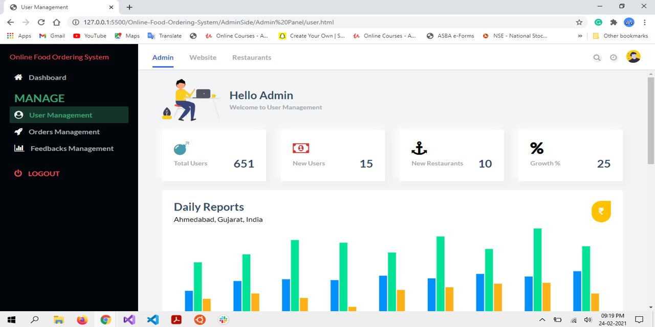

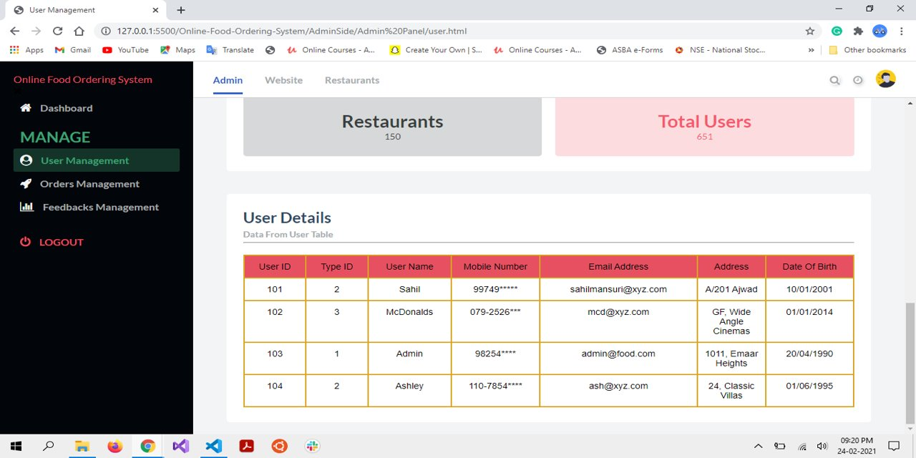

**SR. NO. 1 SCREEN LAYOUTS**

1. **Order Management Screen:**

**DESCRIPTION**:

* + Here the admin can view and manage order details.

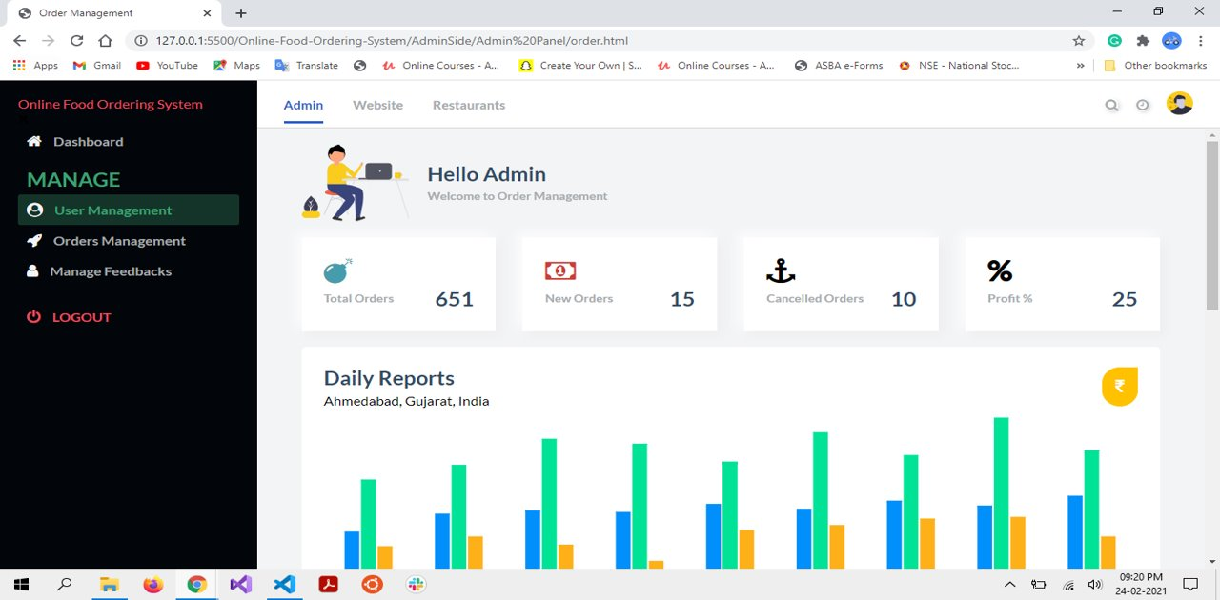

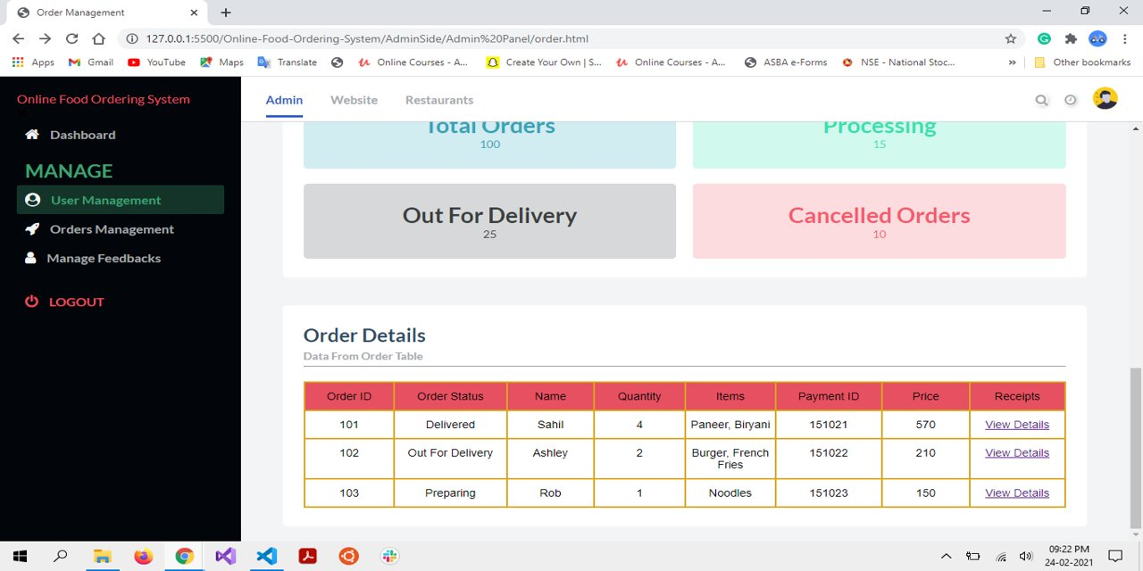

**SR. NO. 1 SCREEN LAYOUTS**

1. **Feedback Management Screen:**

**DESCRIPTION**:

* + Here the admin can view and manage feedbacks.

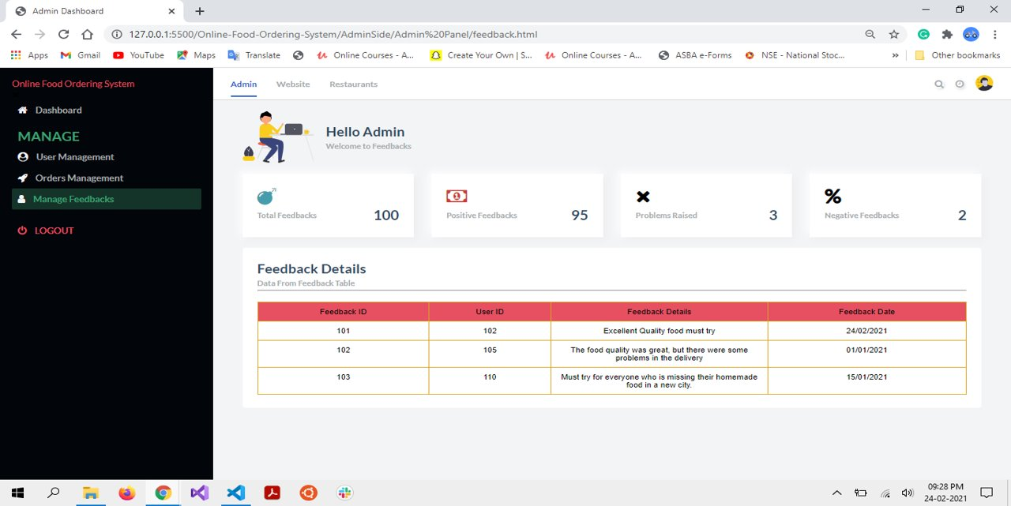

**SR. NO. 1 SCREEN LAYOUTS**

**1.2. RESTAURANT LAYOUTS**

1. **Sign-up:**

**DESCRIPTION**:

* + New restaurants first need to sign-up into our website, in order to run restaurants online. Every field is mandatory for sign-up.

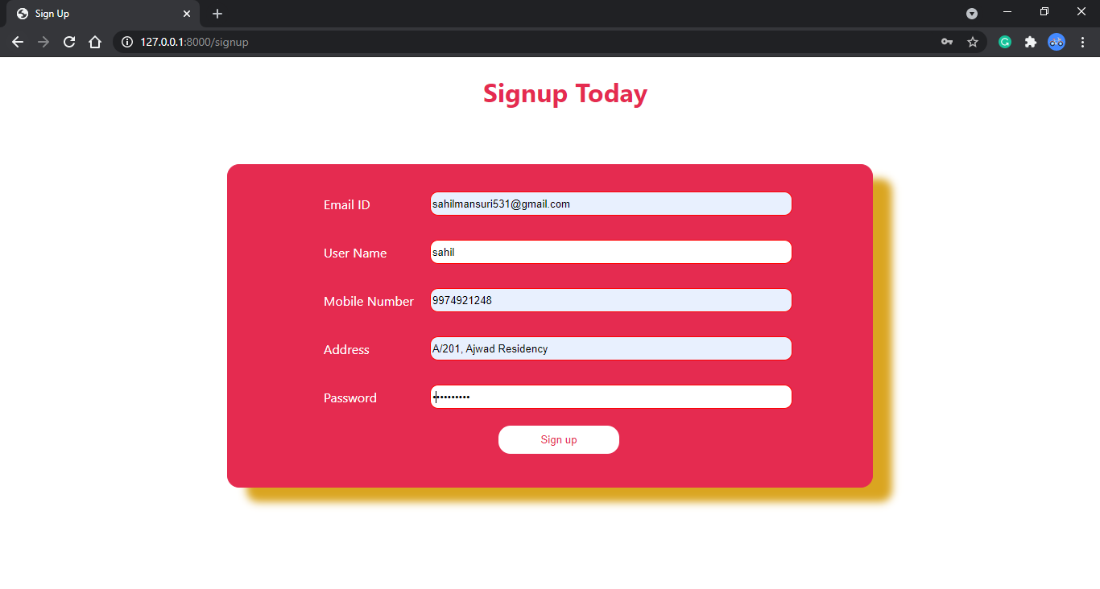

**SR. NO. 1 SCREEN LAYOUTS**

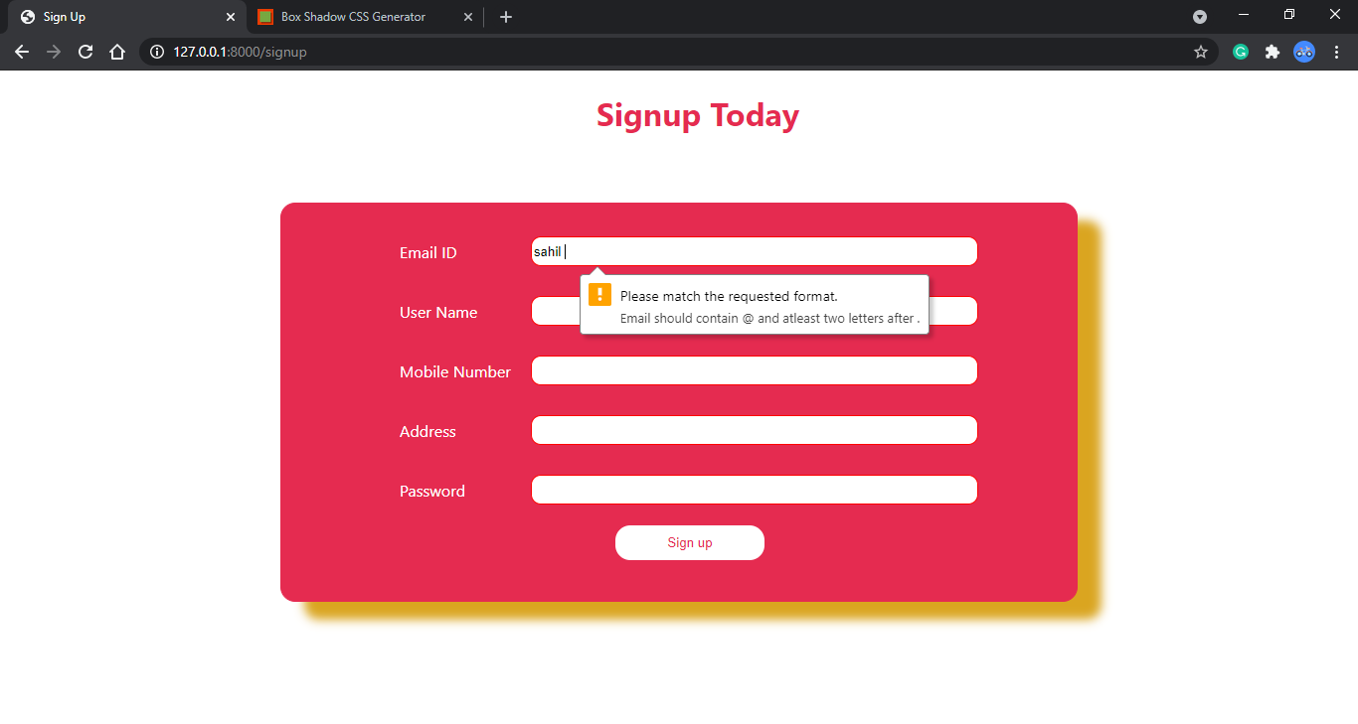

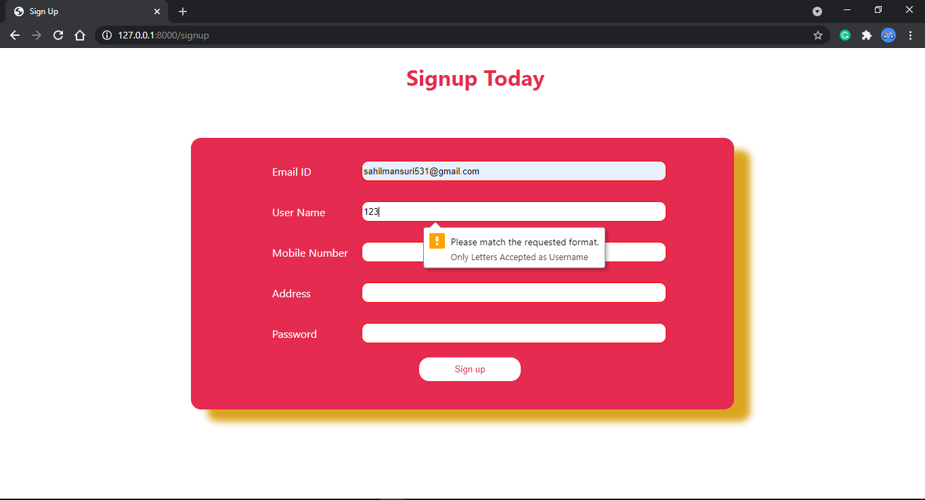

**SR. NO. 1 SCREEN LAYOUTS**

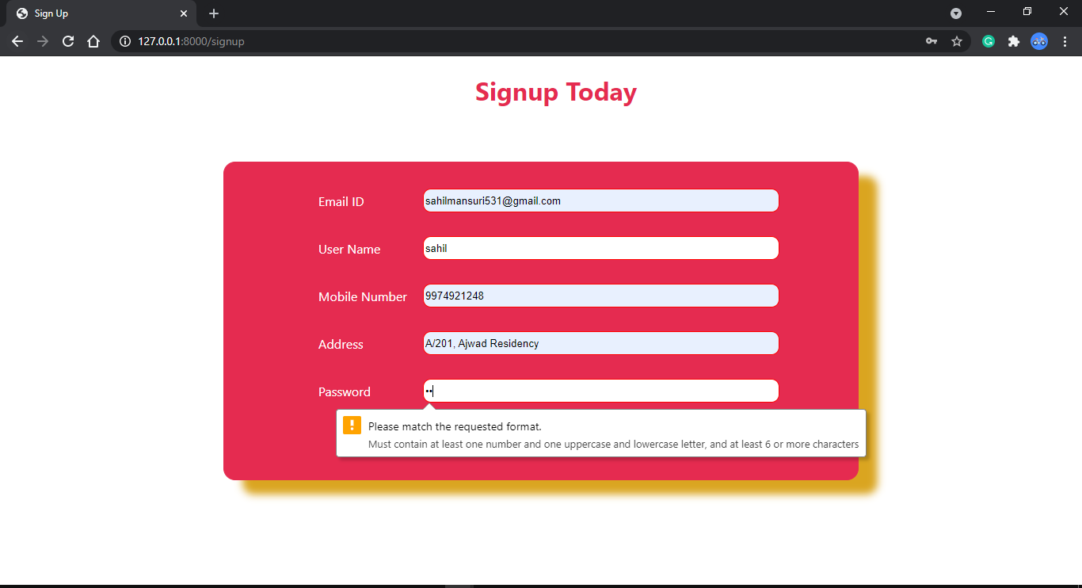

**SR. NO. 1 SCREEN LAYOUTS**

1. **Login Screen:**

**DESCRIPTION:**

* + The user needs to fill both username and password. Both fields are mandatory.



**SR. NO. 1 SCREEN LAYOUTS**





**SR. NO. 1 SCREEN LAYOUTS**

1. **Restaurant Dashboard:**

**DESCRIPTION:**

* + When the restaurant enters correct username and password, it immediately navigates to dashboard.

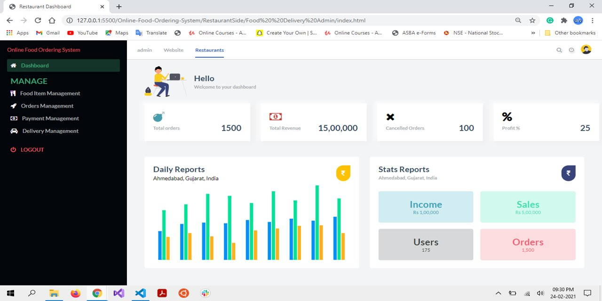

**SR. NO. 1 SCREEN LAYOUTS**

1. **Food Item Management Screen:**

**DESCRIPTION:**

* + From here, Restaurants can view and manage food items.

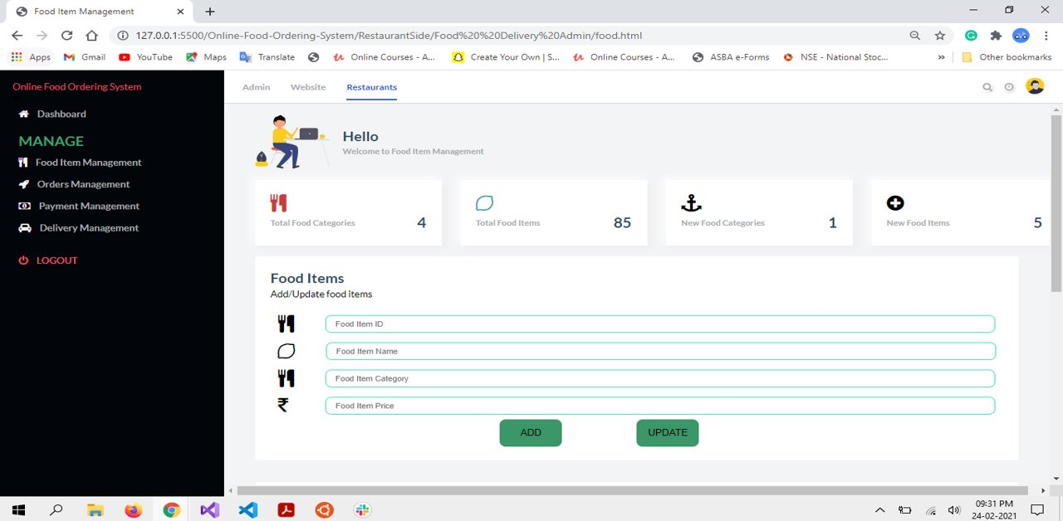

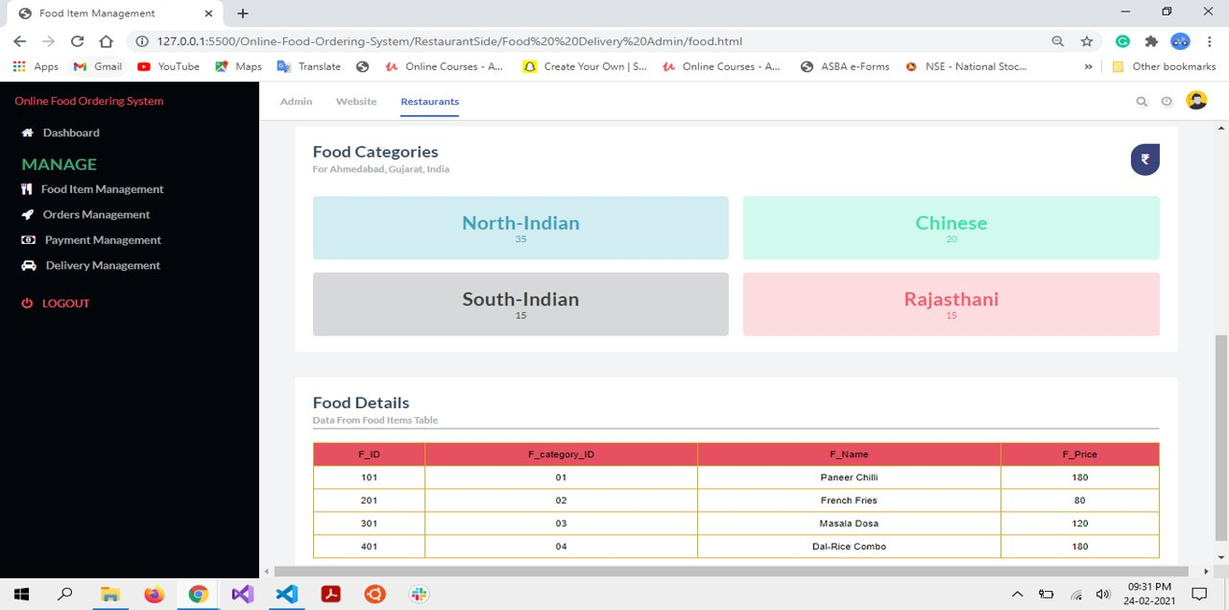

**SR. NO. 1 SCREEN LAYOUTS**

1. **Orders Management Screen:**

**DESCRIPTION:**

* + From here, Restaurants can view and manage order details.

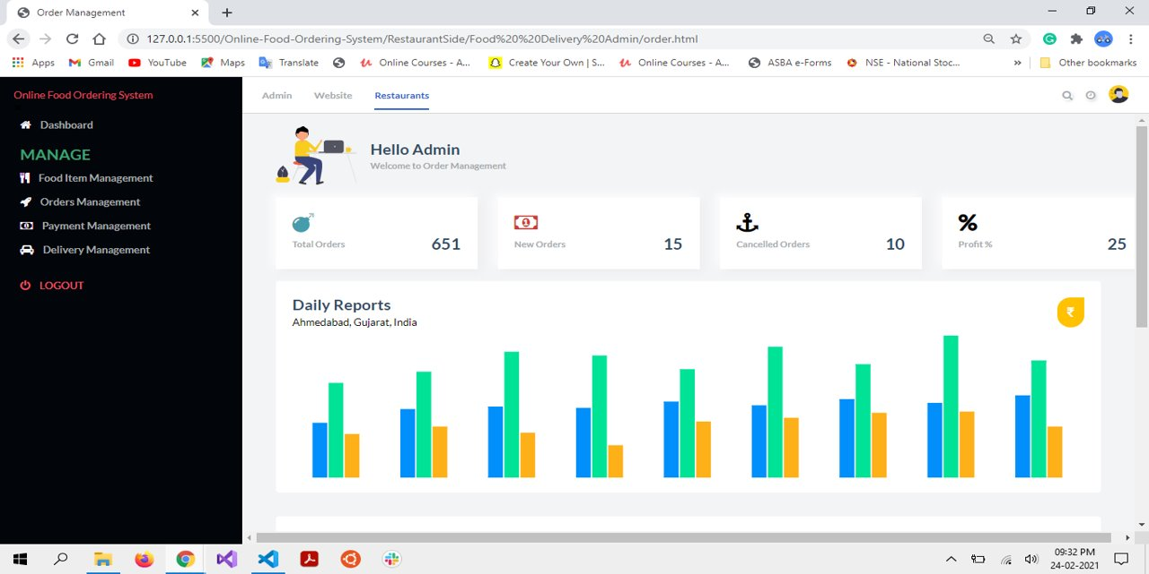

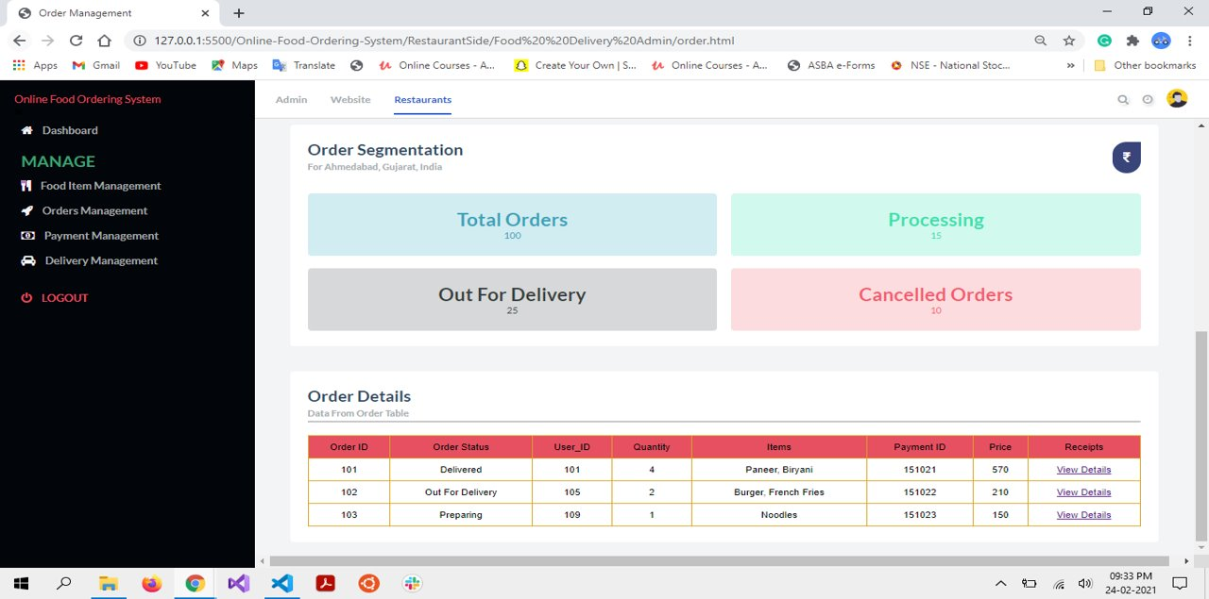

**SR. NO. 1 SCREEN LAYOUTS**

1. **Payment Management Screen:**

**DESCRIPTION:**

* + From here, Restaurants can view and manage payment details.

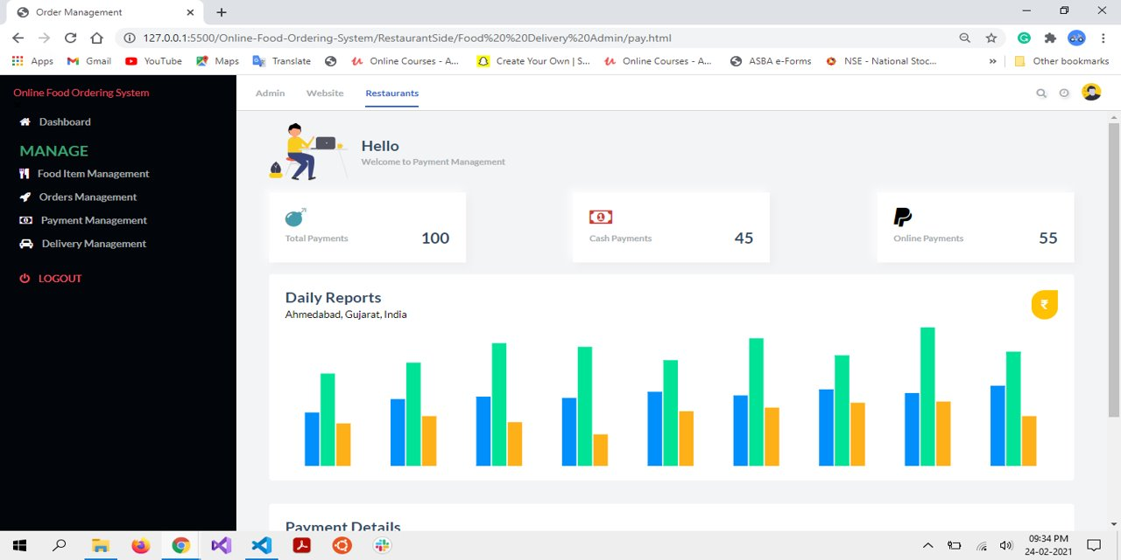

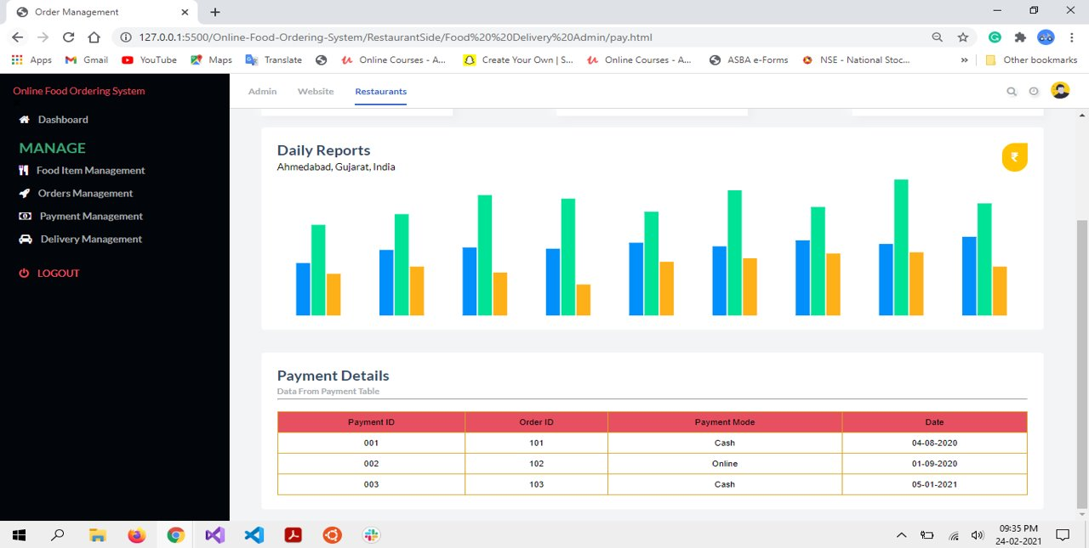

**SR. NO. 1 SCREEN LAYOUTS**

1. **Delivery Management Screen:**

**DESCRIPTION:**

* + From here, Restaurants can view and manage delievery details.

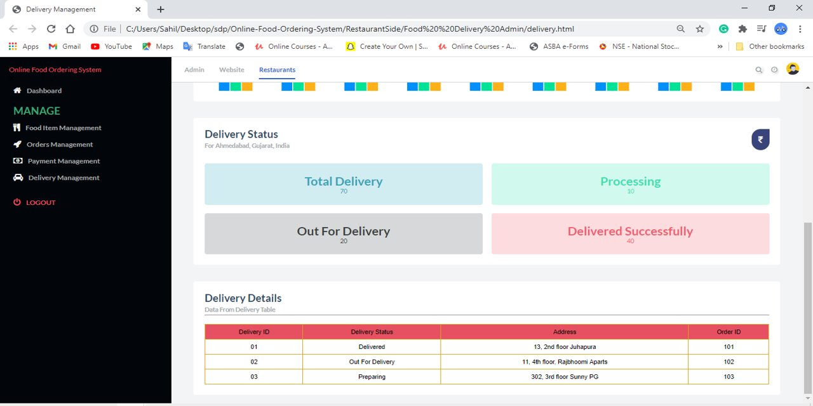

**SR. NO. 1 SCREEN LAYOUTS**

**1.3. USER LAYOUTS**

1. **Sign-up:**

**DESCRIPTION**:

* + New users first need to sign-up into our website, to order food online. Every field is mandatory for sign-up.

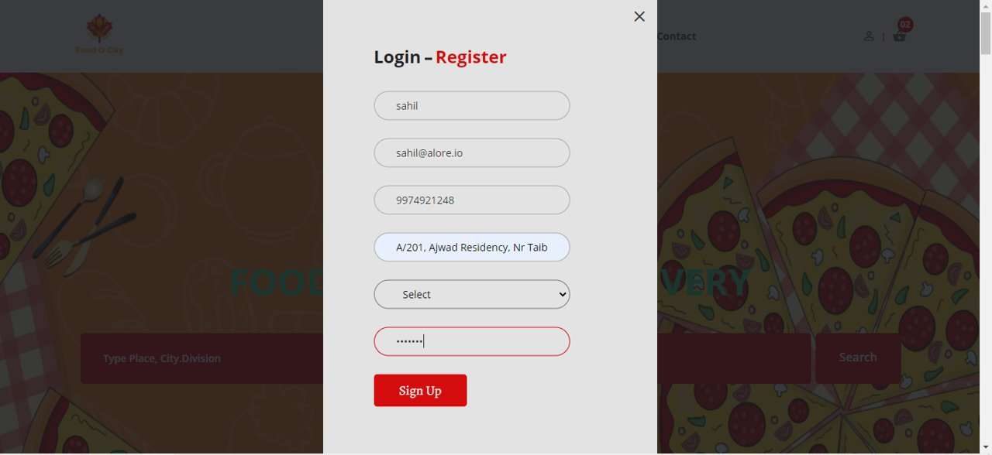

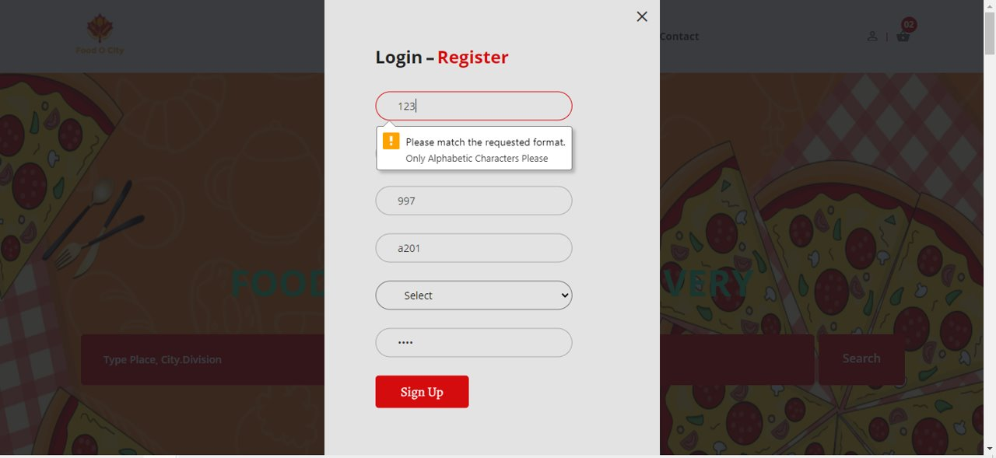

**SR. NO. 1 SCREEN LAYOUTS**

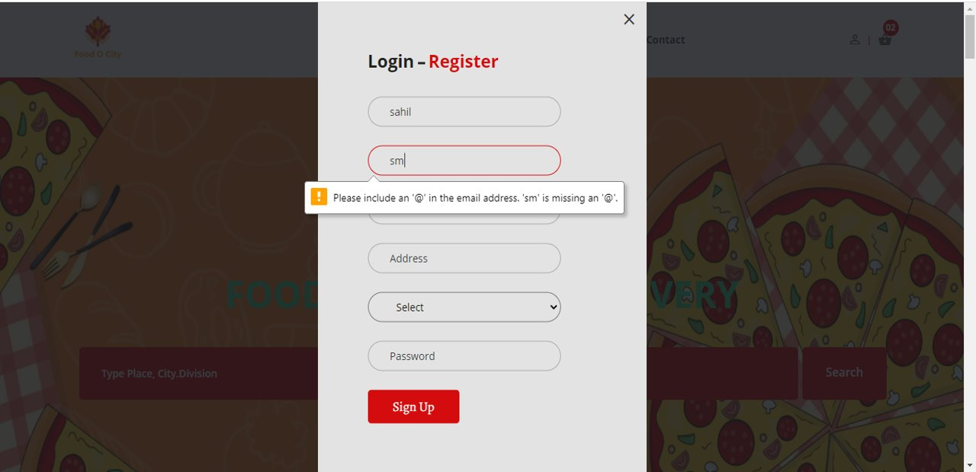

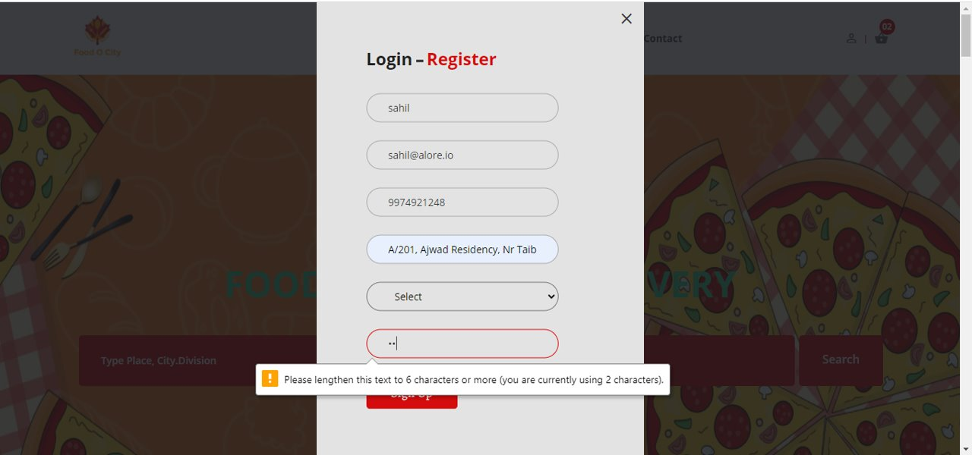

**SR. NO. 1 SCREEN LAYOUTS**

1. **Login Screen:**

**DESCRIPTION:**

* + The user needs to fill both username and password. Both fields are mandatory.

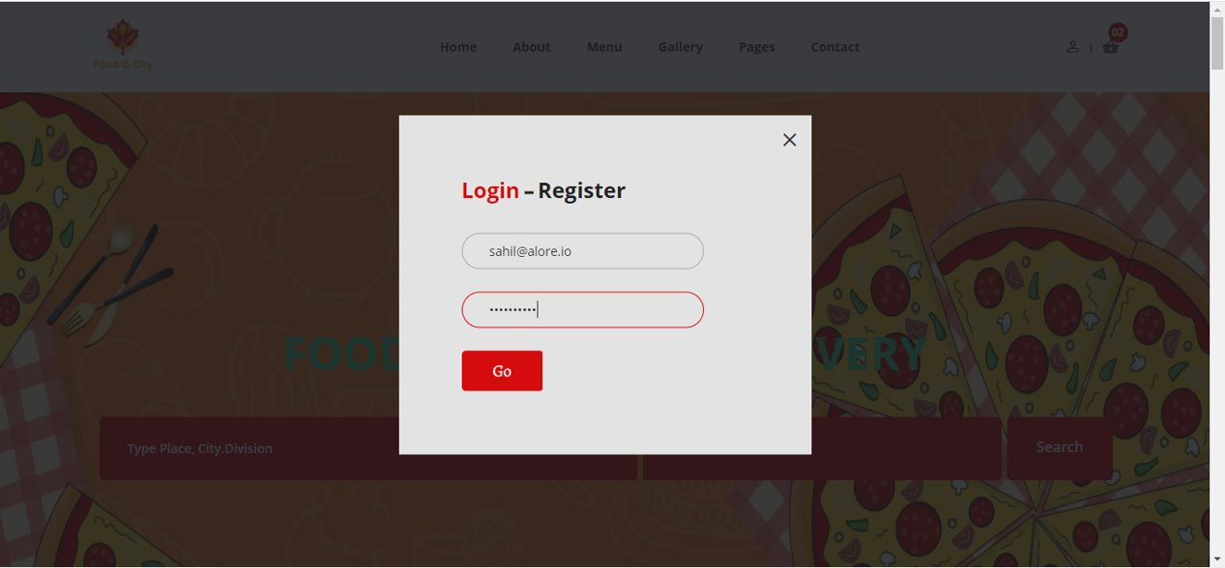

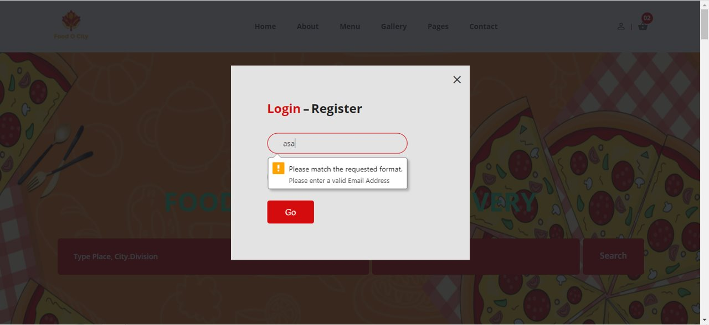

**SR. NO. 1 SCREEN LAYOUTS**

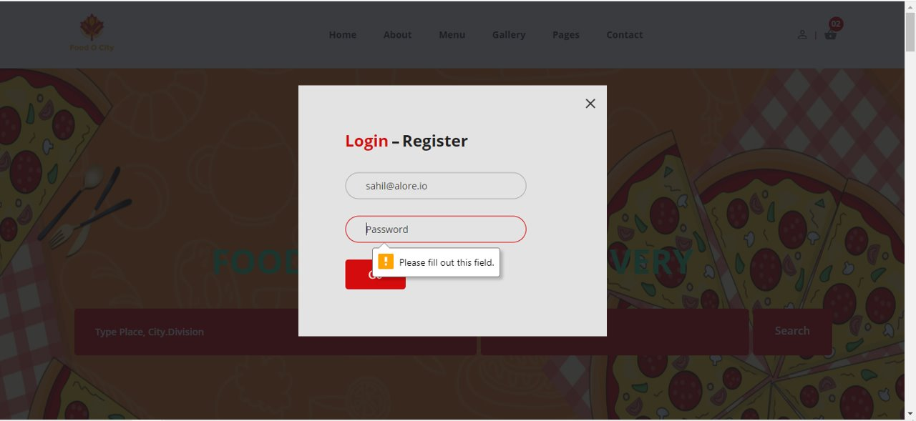

1. **Home Page Screen:**

**DESCRIPTION:**

* + When user login successfully, he gets navigated to home page.

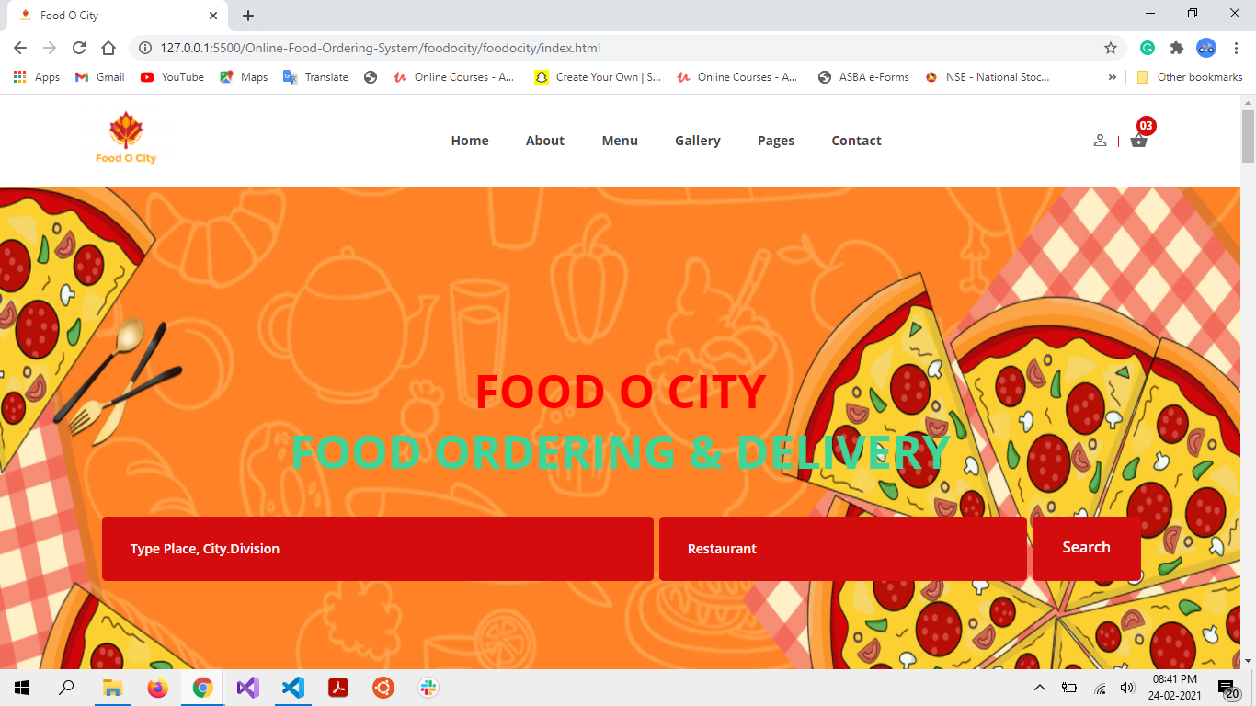

**SR. NO. 1 SCREEN LAYOUTS**

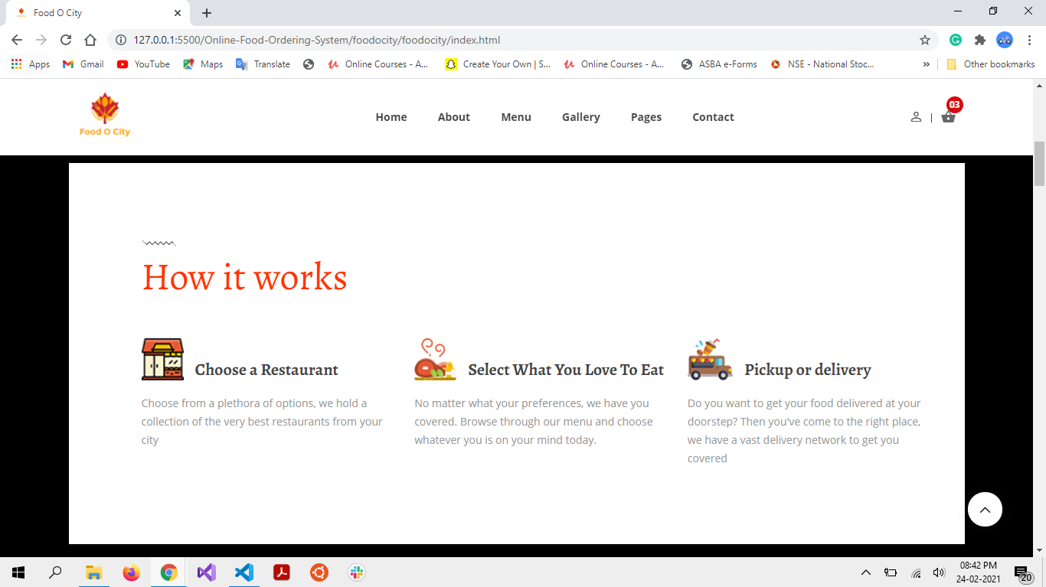

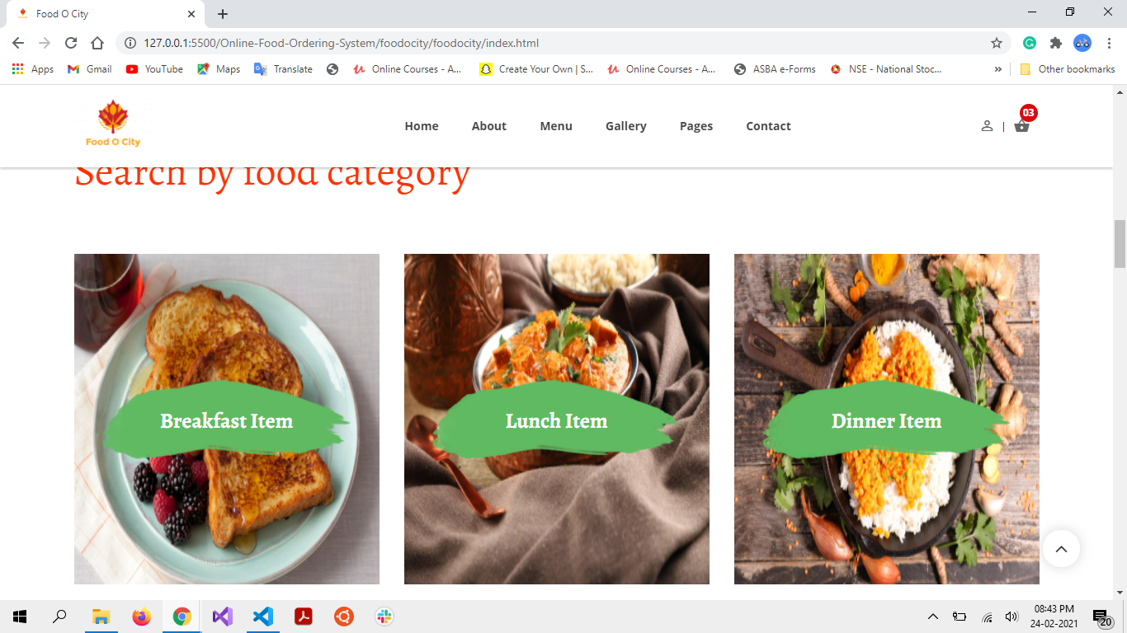

**SR. NO. 1 SCREEN LAYOUTS**

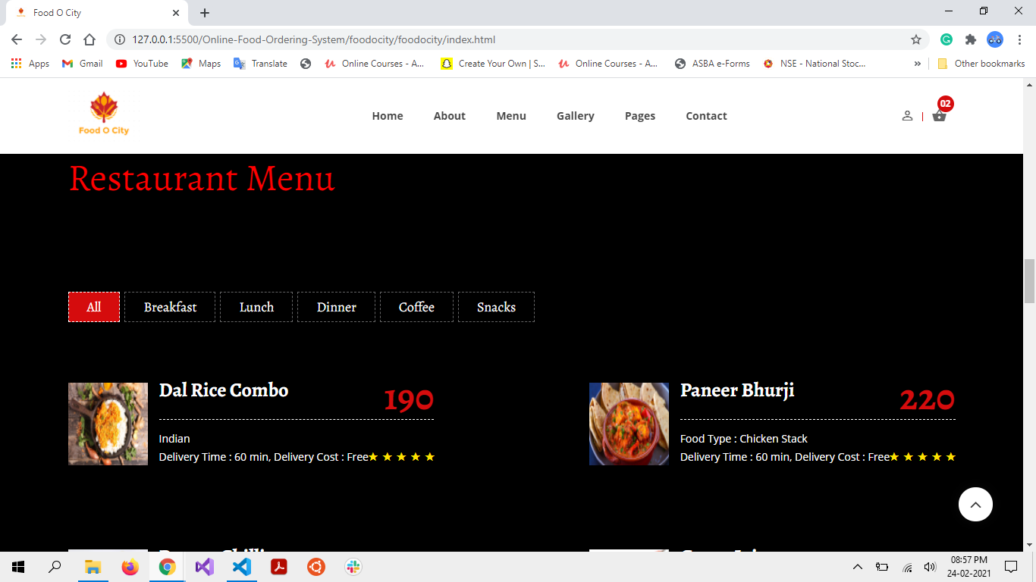

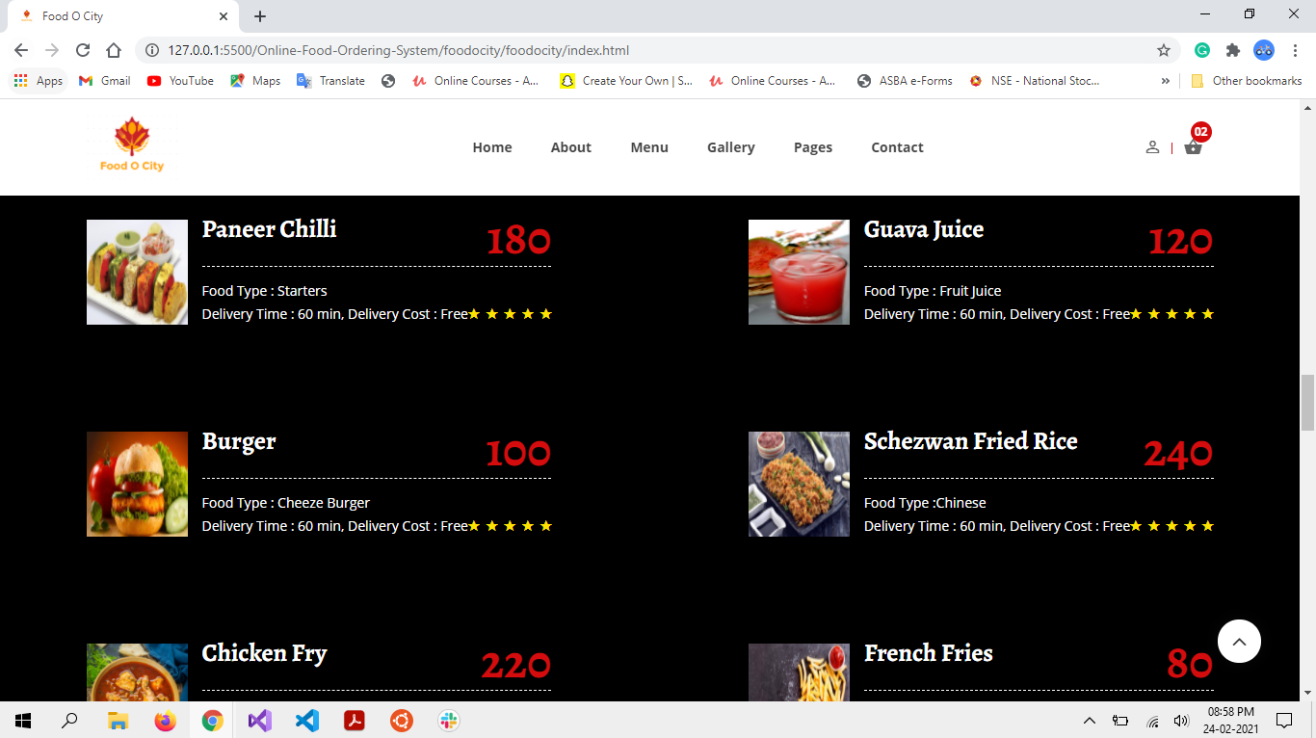

**SR. NO. 1 SCREEN LAYOUTS**

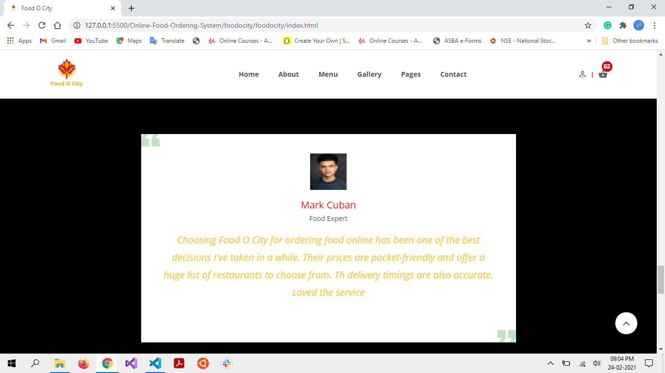

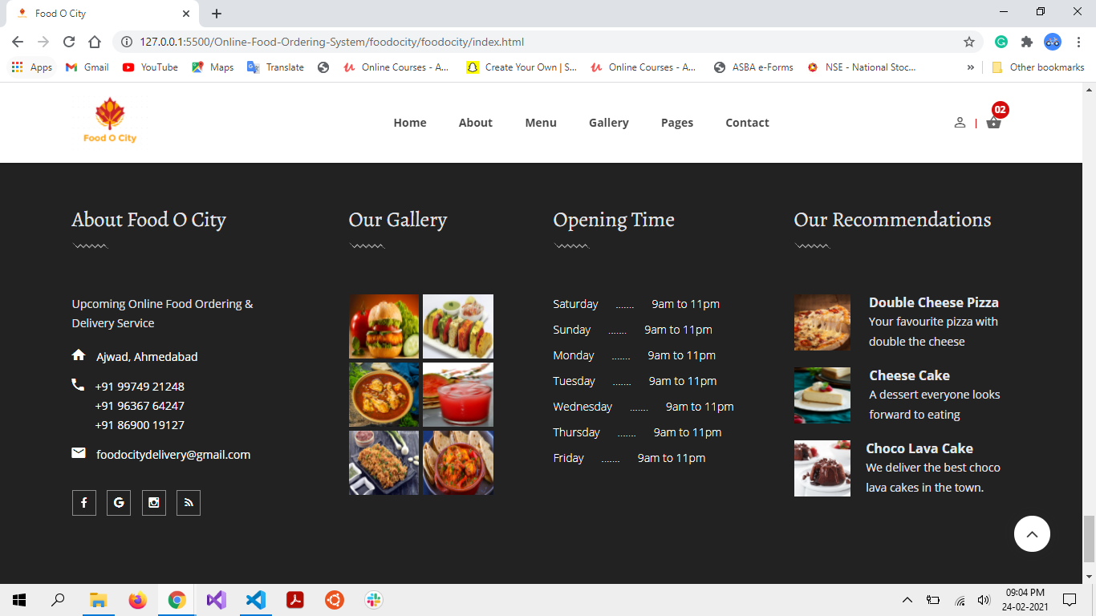

**SR. NO. 1 SCREEN LAYOUTS**

1. **About Us Screen:**

**DESCRIPTION:**

* + Through this, user can know more about our website and view FAQs.

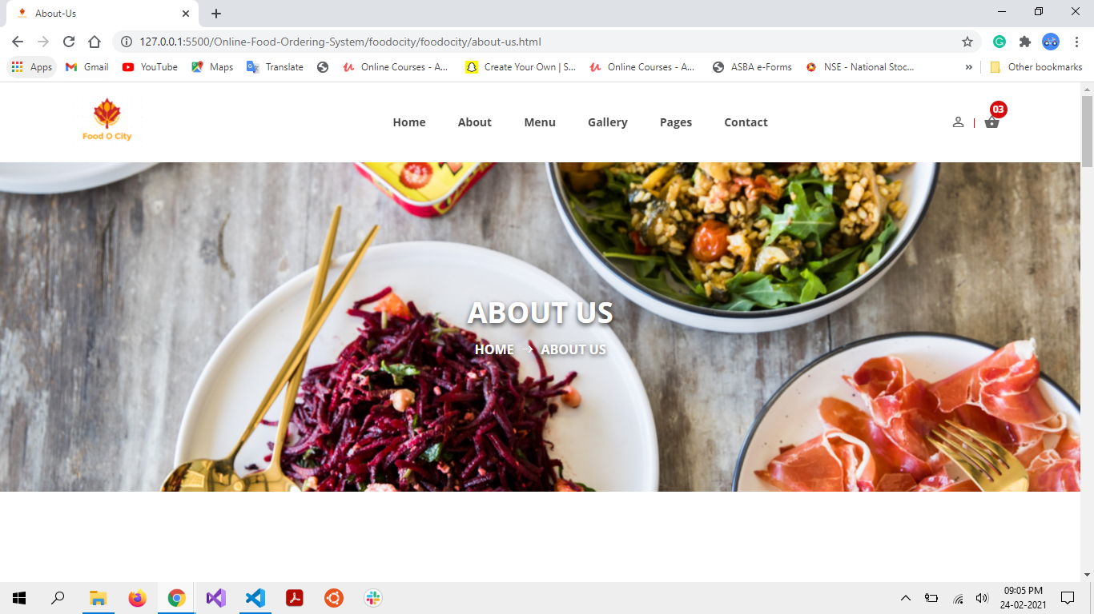

**SR. NO. 1 SCREEN LAYOUTS**

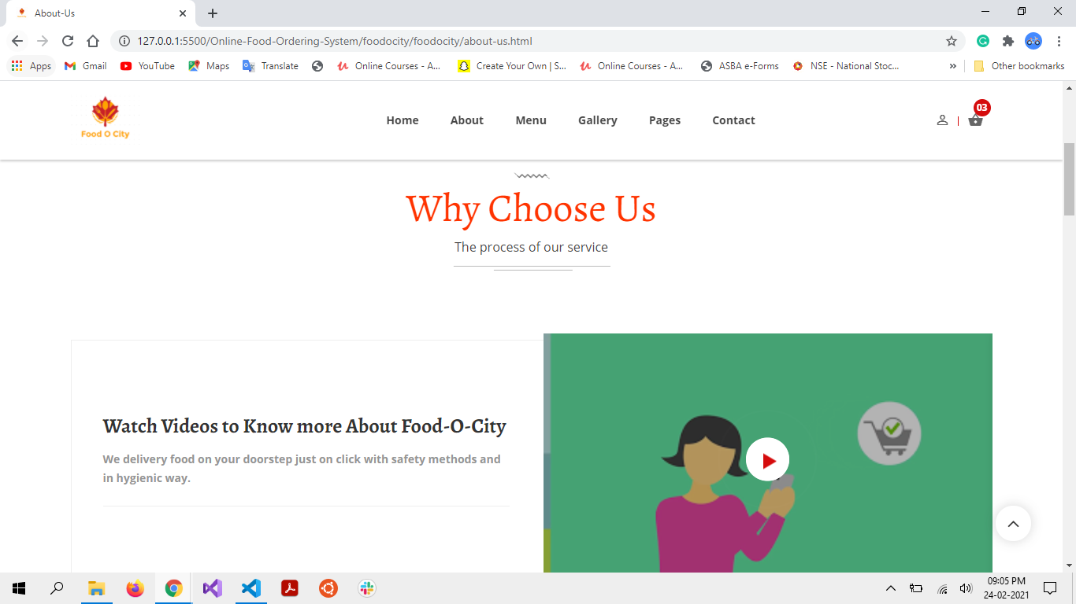

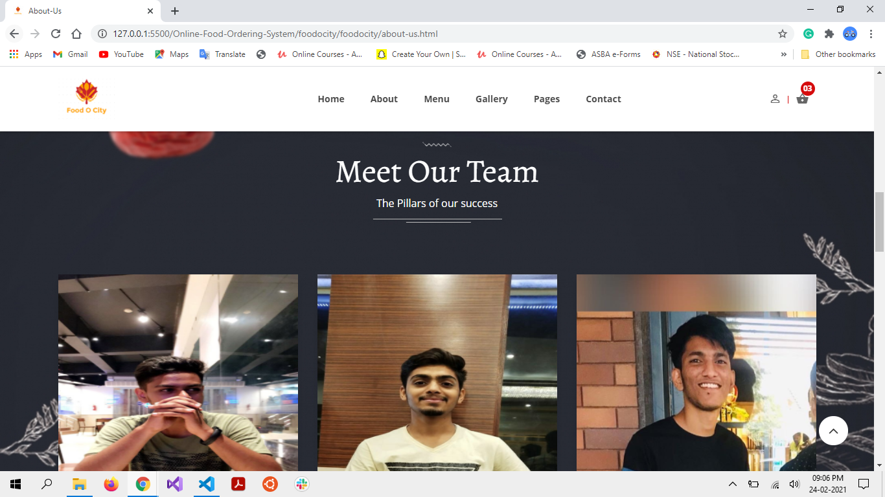

**SR. NO. 1 SCREEN LAYOUTS**

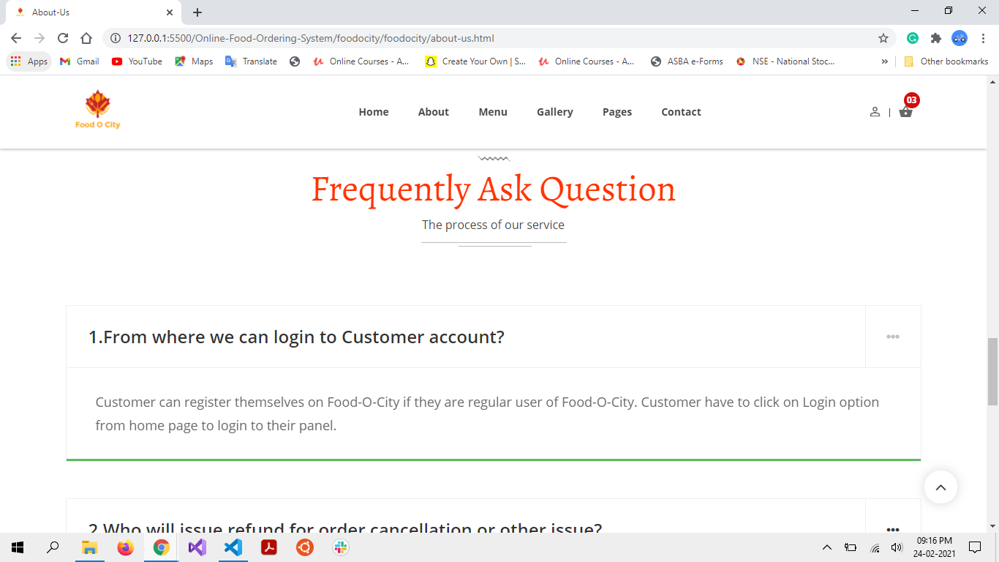

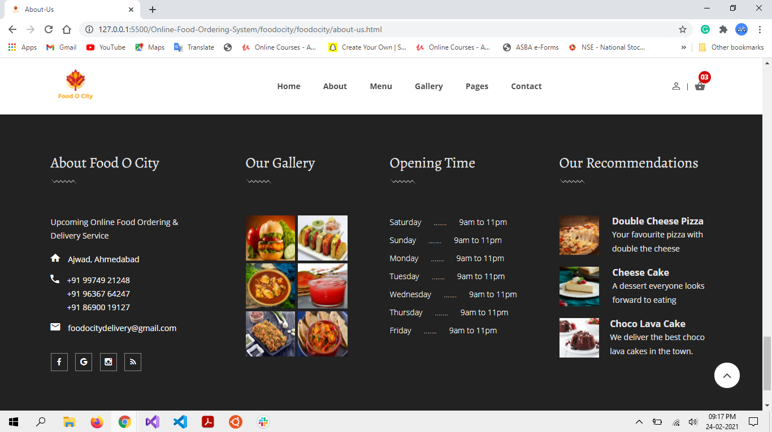

**SR. NO. 1 SCREEN LAYOUTS**

1. **Menu Screen:**

**DESCRIPTION:**

* + Through this, user can view and add different food items for ordering.

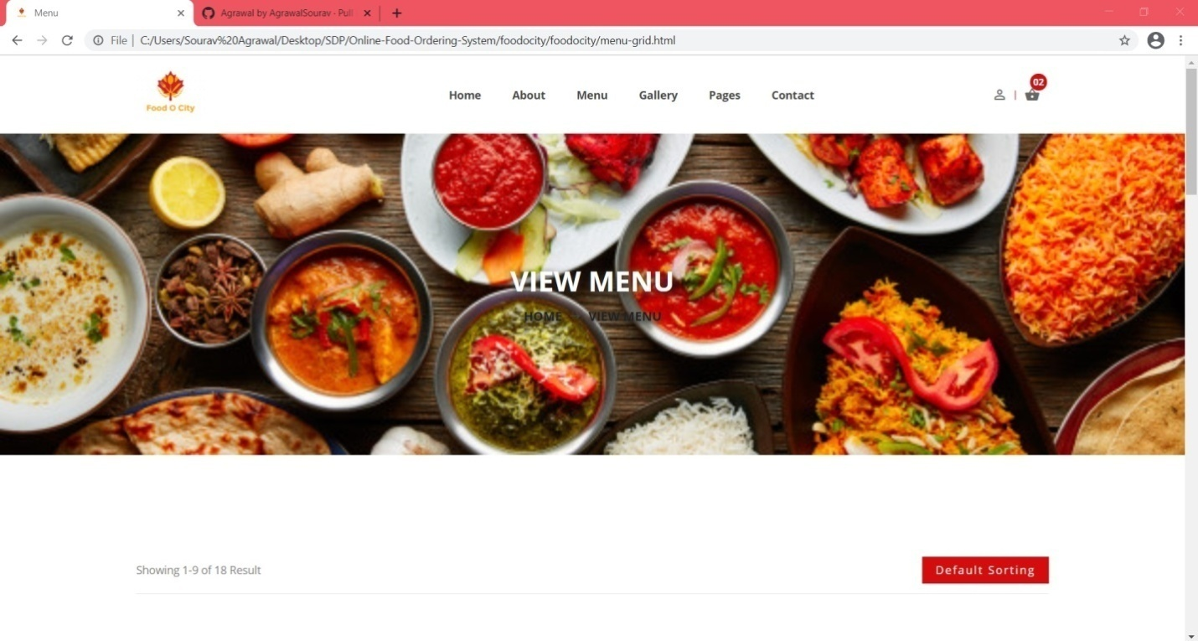

**SR. NO. 1 SCREEN LAYOUTS**

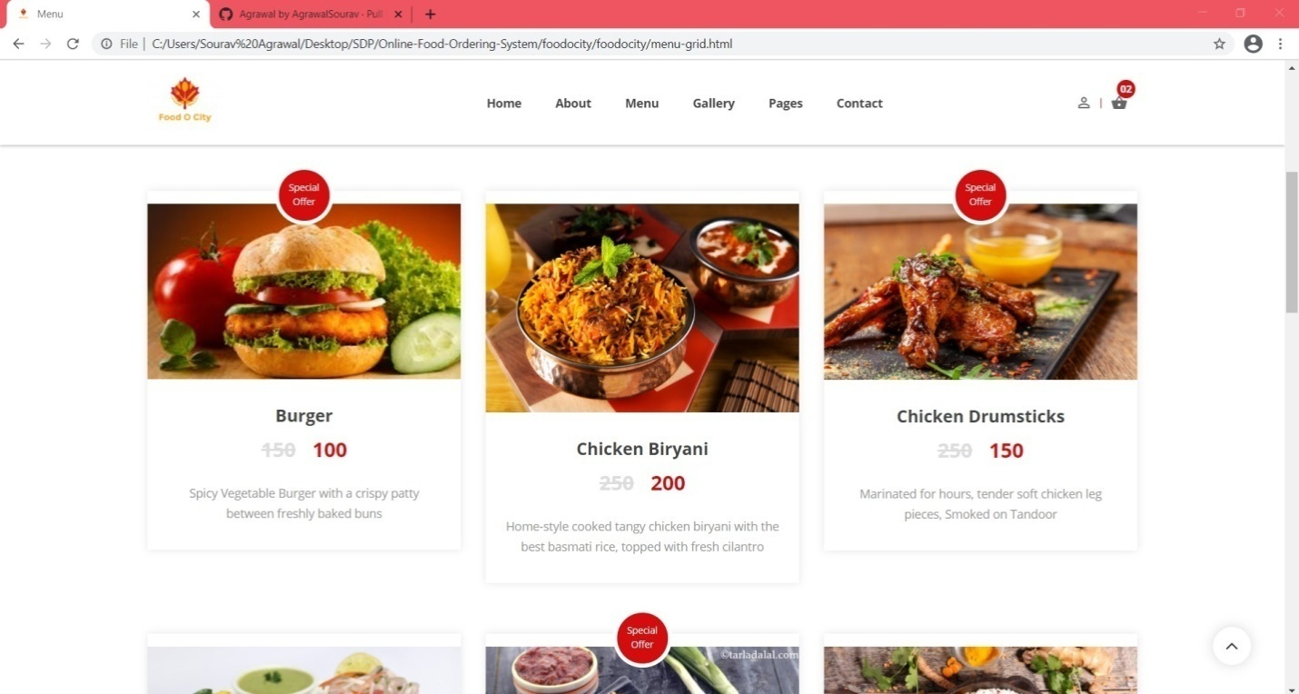

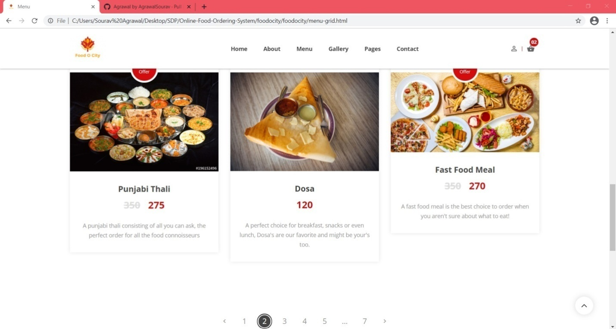

**SR. NO. 1 SCREEN LAYOUTS**

1. **Food Item Gallery Screen:**

**DESCRIPTION:**

* + User can view different food items from the food gallery.

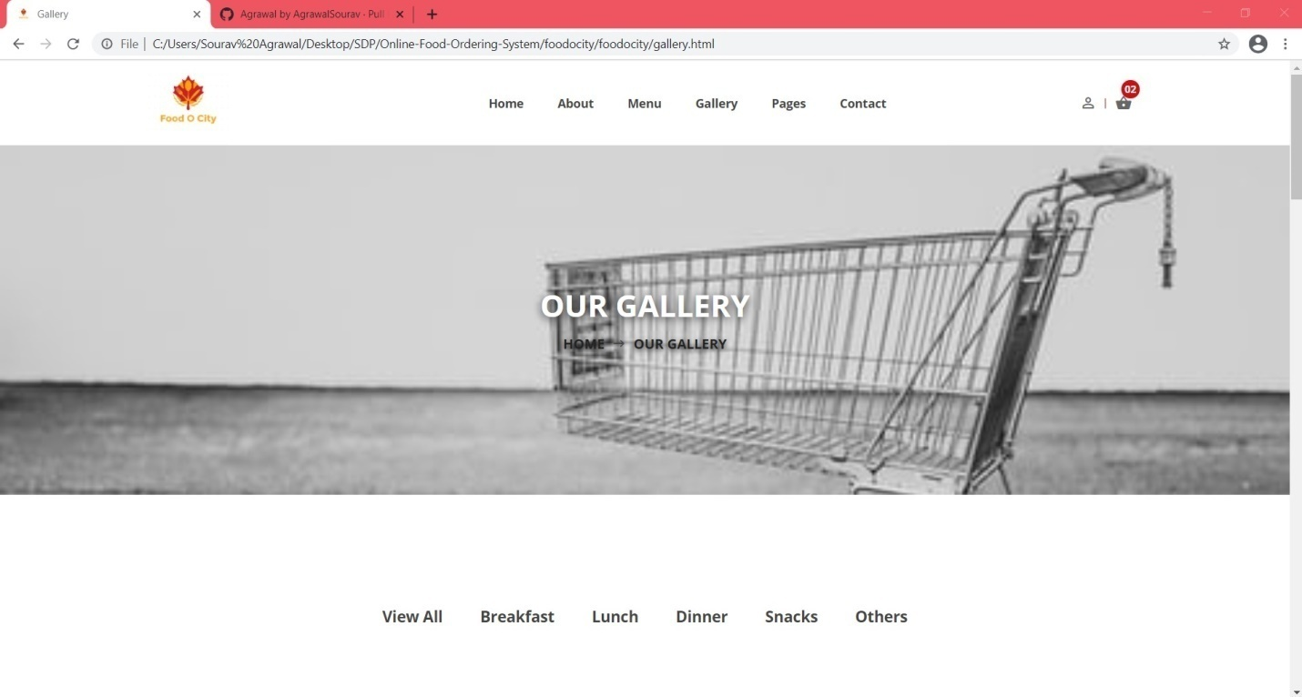

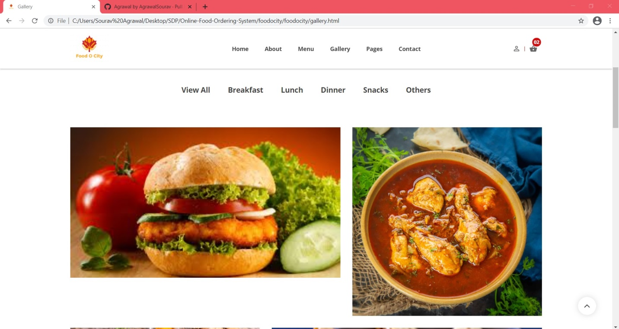

**SR. NO. 1 SCREEN LAYOUTS**

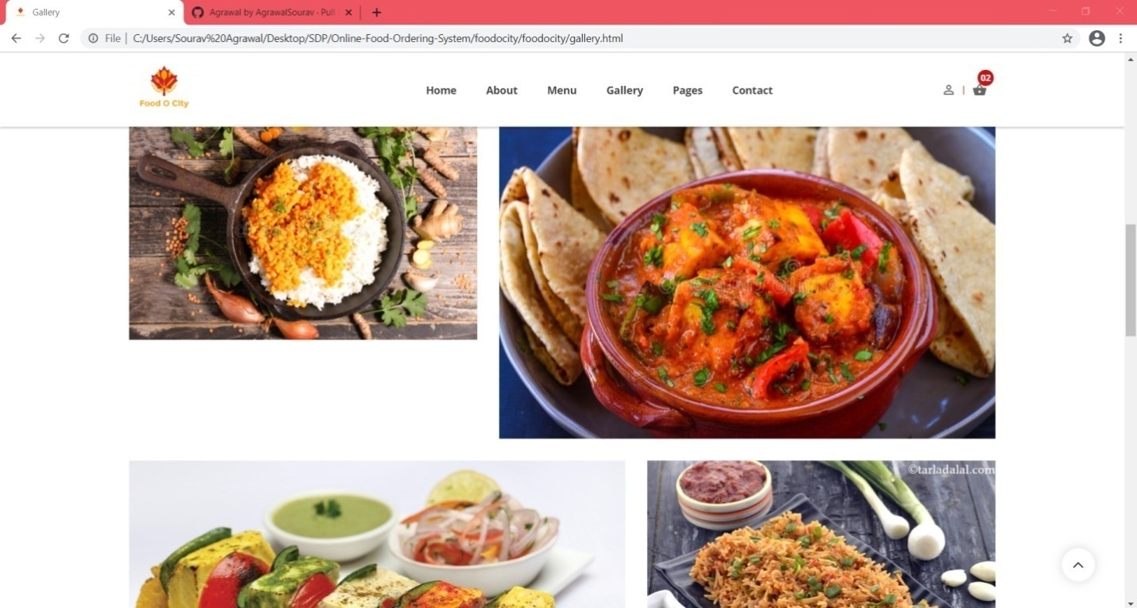

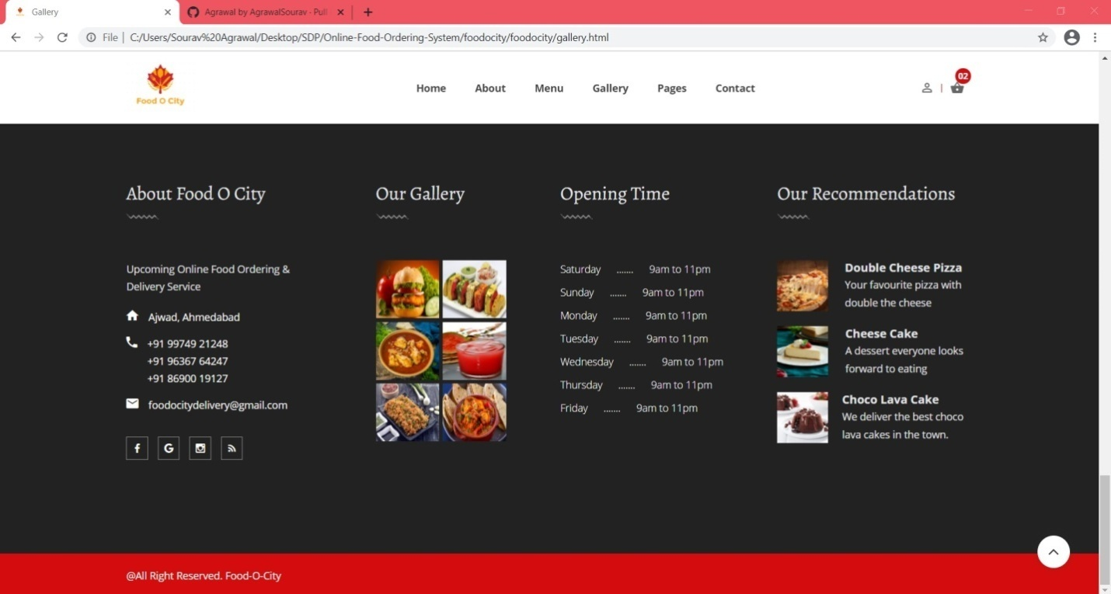

**SR. NO. 1 SCREEN LAYOUTS**

1. **Cart Page Screen:**

**DESCRIPTION:**

* + From cart page, User can view food items that he added in the cart.

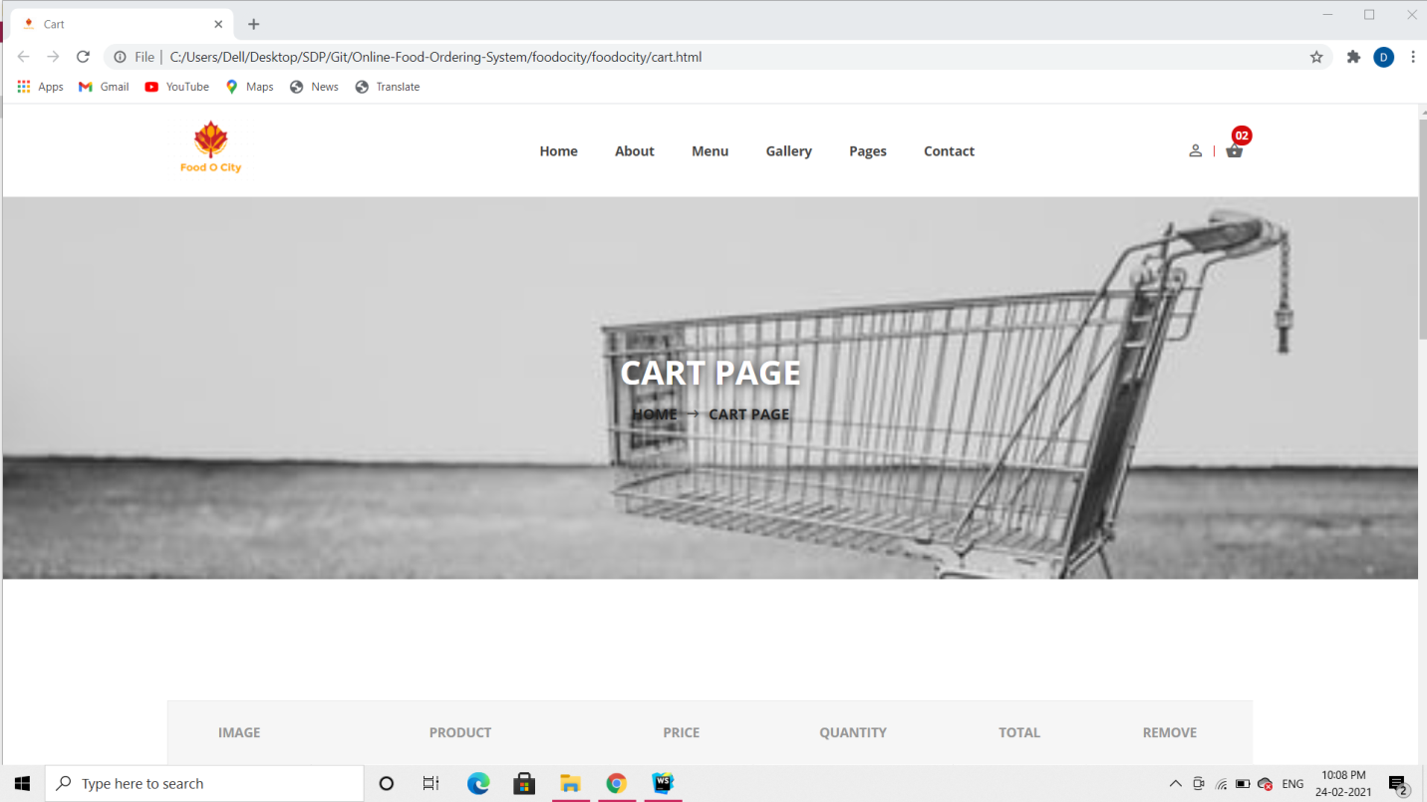

**SR. NO. 1 SCREEN LAYOUTS**

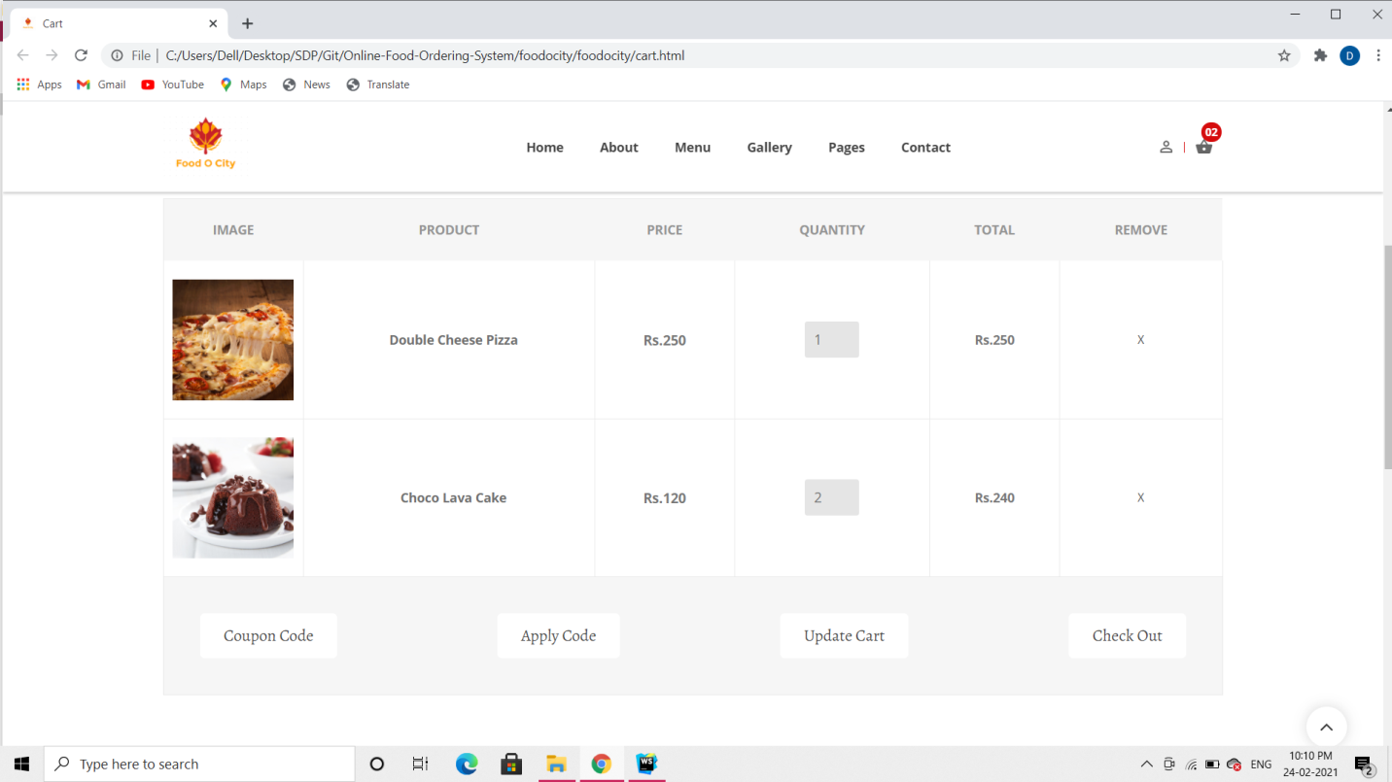

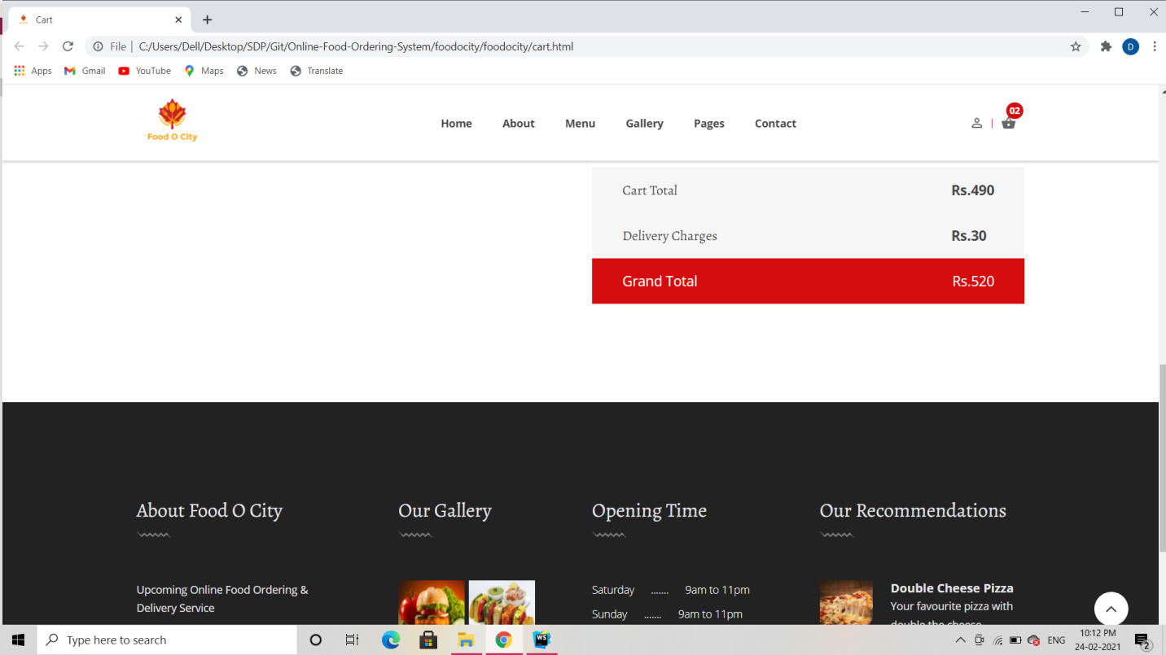

**SR. NO. 1 SCREEN LAYOUTS**

1. **Checkout Page Screen:**

**DESCRIPTION:**

* + User can enter the delivery address, select payment method and view order total through checkout page.

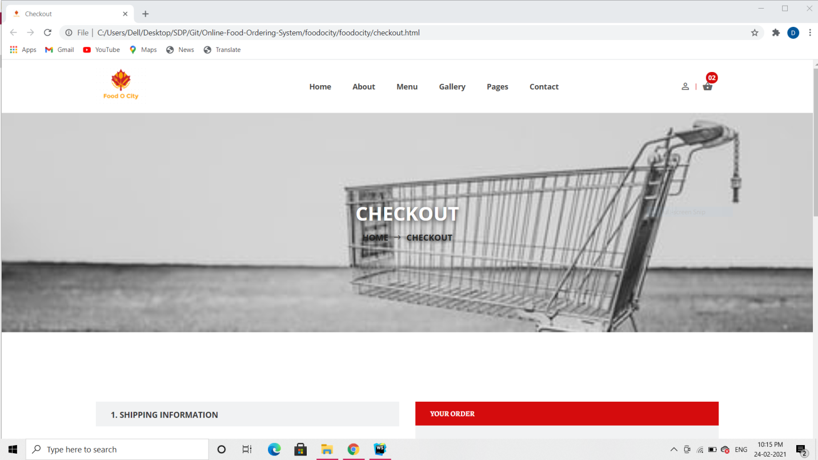

**SR. NO. 1 SCREEN LAYOUTS**

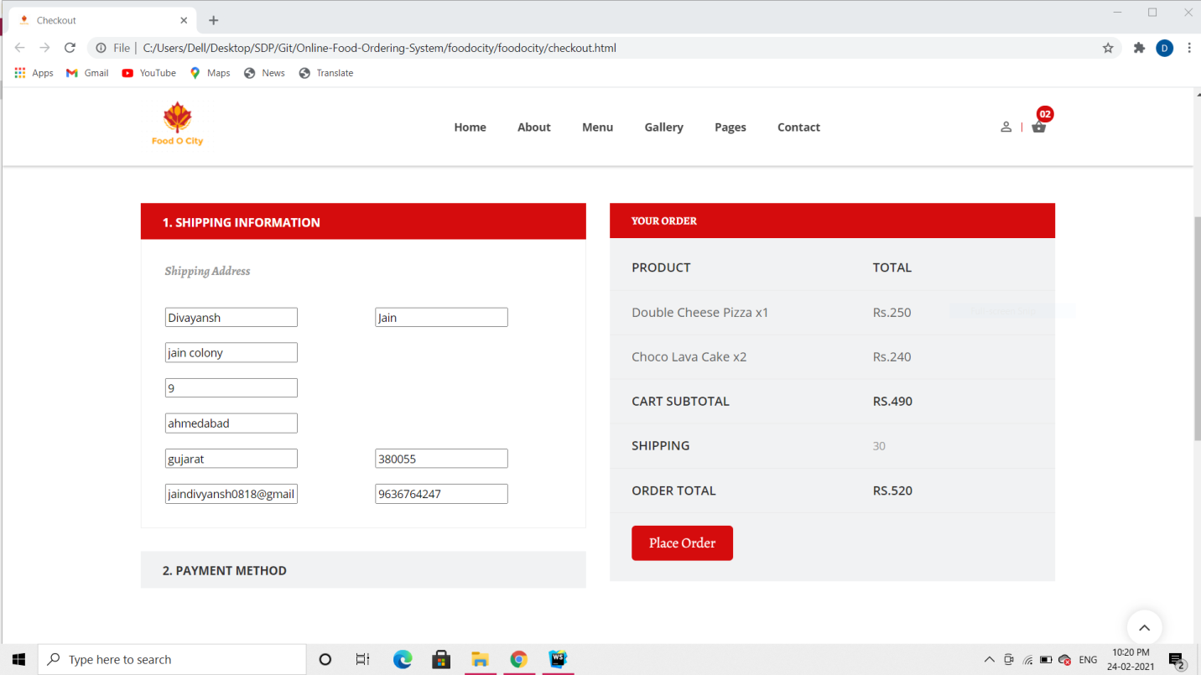

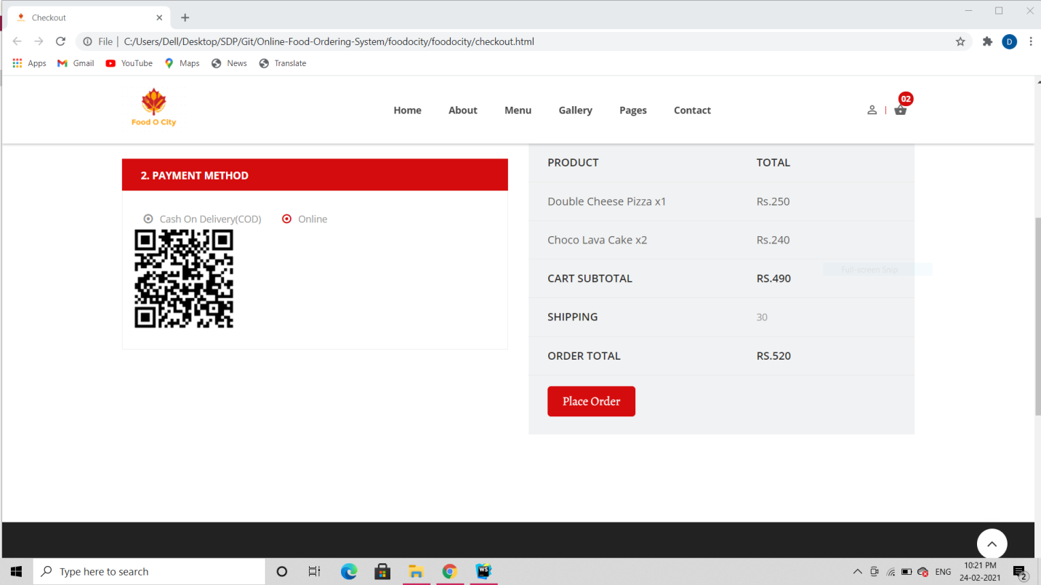

**SR. NO. 1 SCREEN LAYOUTS**

1. **Service Page Screen:**

**DESCRIPTION:**

* + From here, user can view what services do we provide.

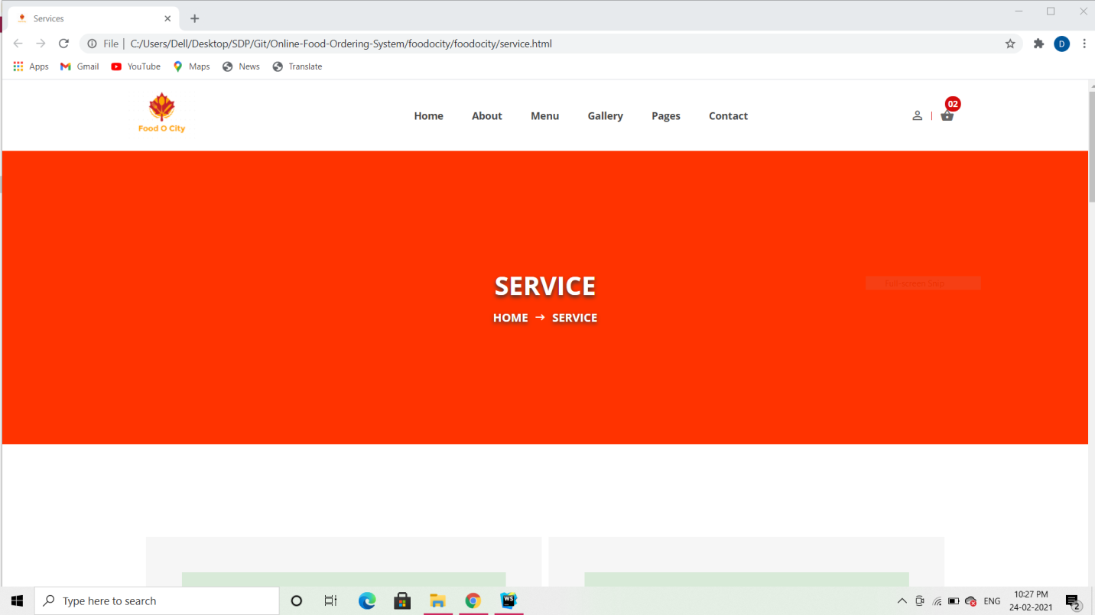

**SR. NO. 1 SCREEN LAYOUTS**

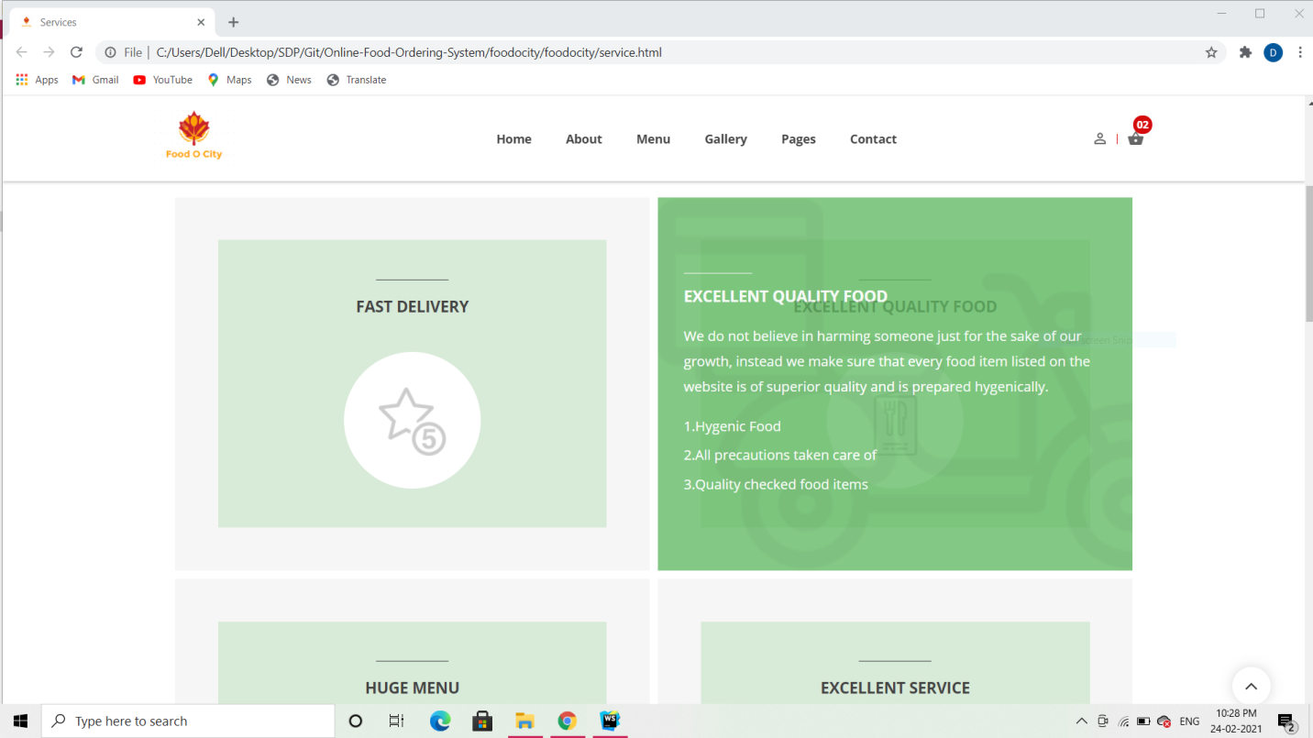

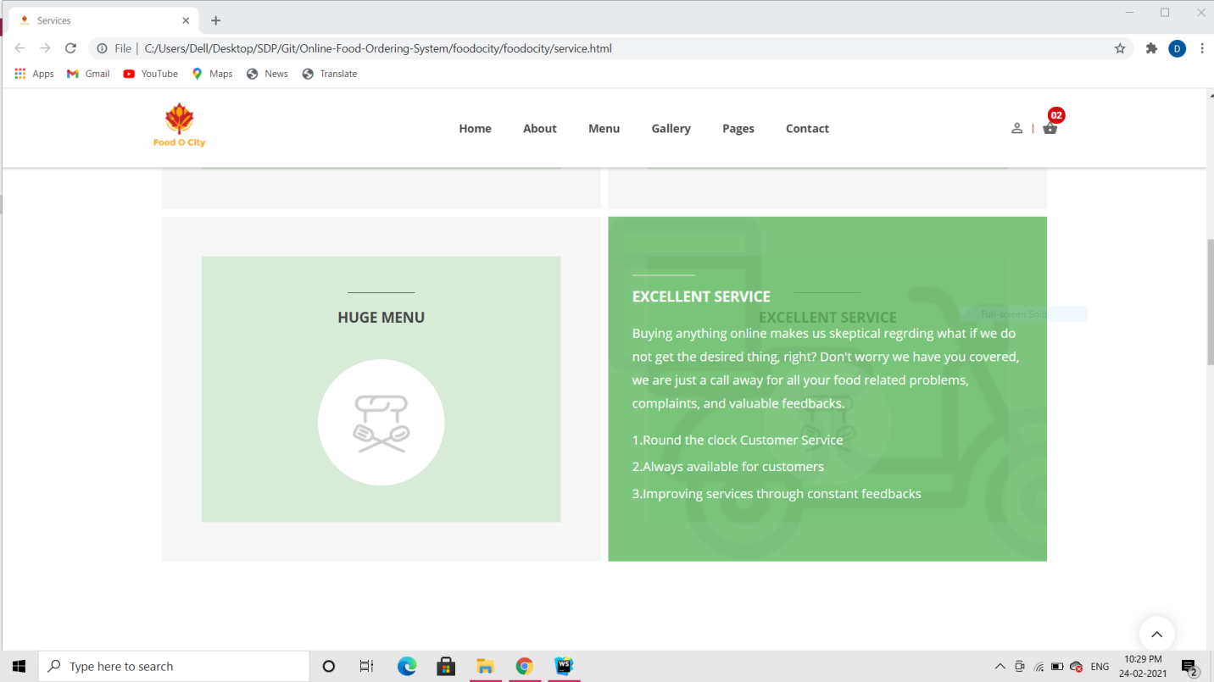

**SR. NO. 1 SCREEN LAYOUTS**

1. **Contact Us Page Screen:**

**DESCRIPTION:**

* + From here, user can get in touch with us.

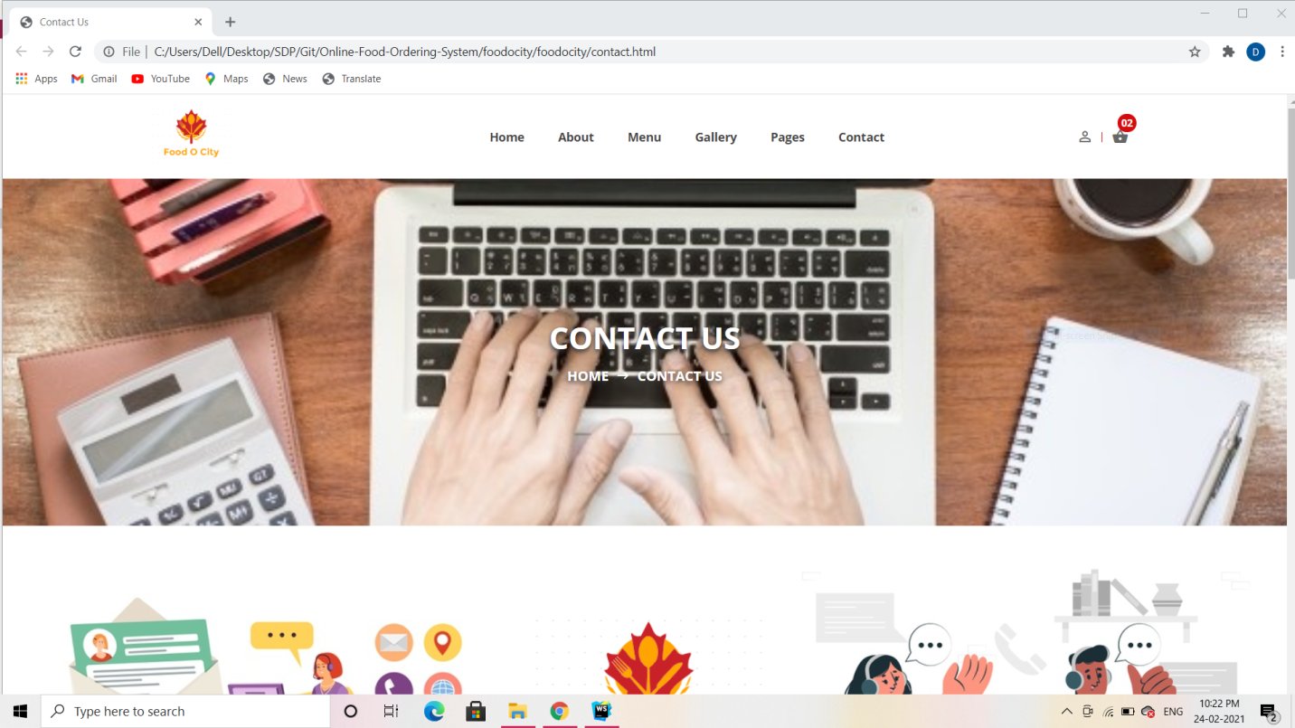

**SR. NO. 1 SCREEN LAYOUTS**

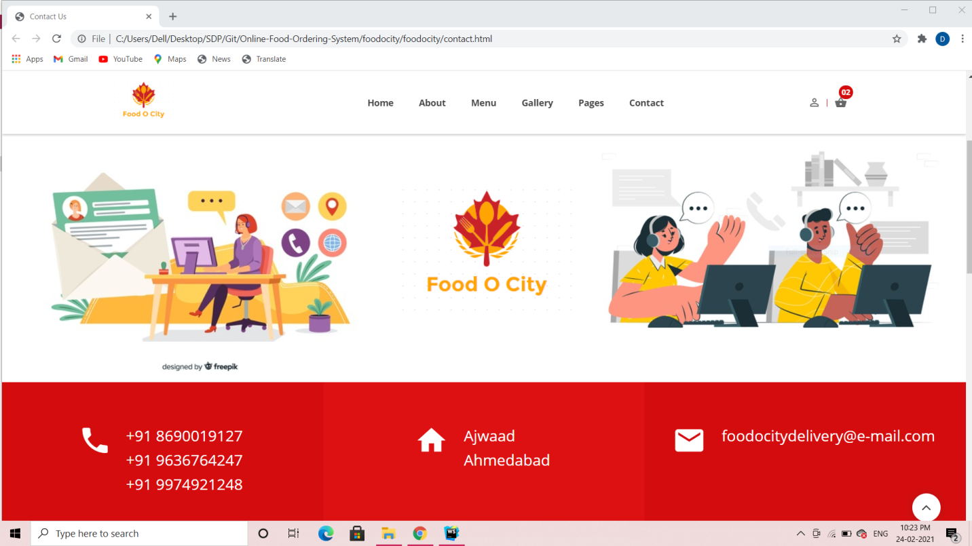

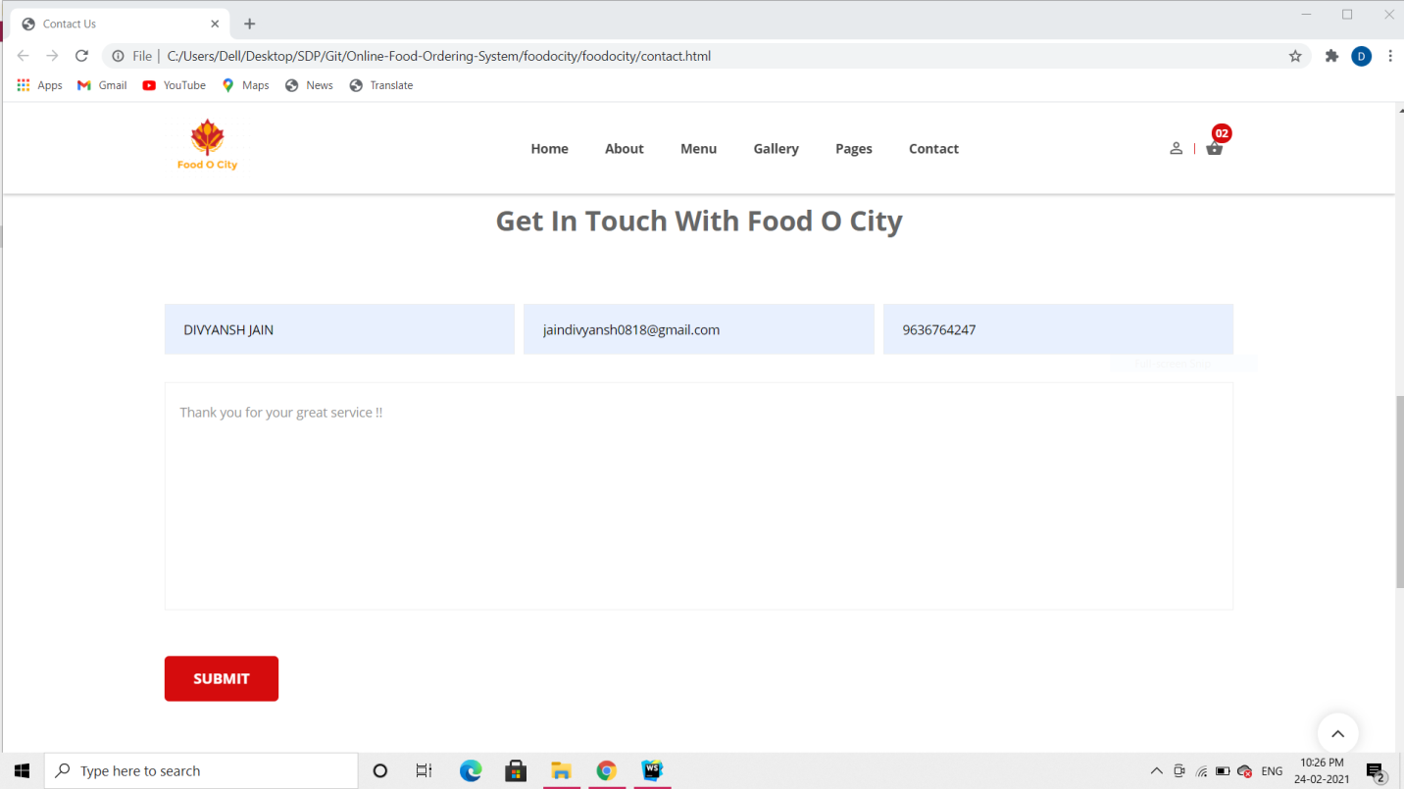

**SR. NO. 1 SCREEN LAYOUTS**

1. **Basket Icon Screen:**

**DESCRIPTION:**

* + User can quickly see the food items that he added using basket icon.

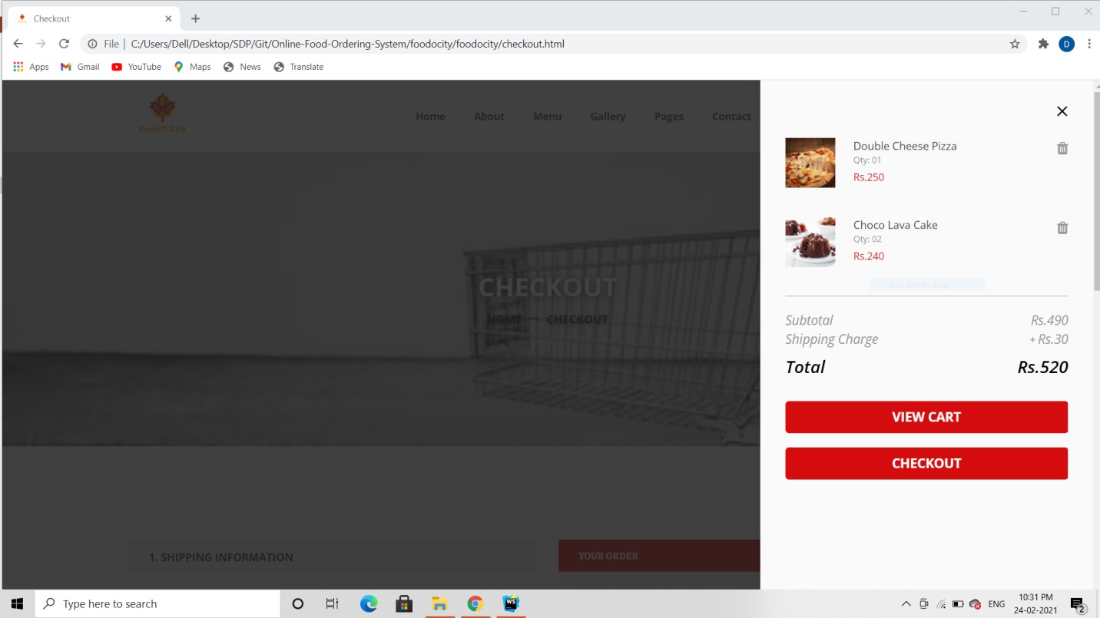

**SR. NO. 2 REPORT LAYOUTS**

**Report Layouts**

* 1. **Report For Payments:**

**Description:**

This Report fetches data from multiple tables like Payment Table, Order Master Table, and User Table to generate meaningful reports regarding payments made on the website. It also shows the mode of payment.

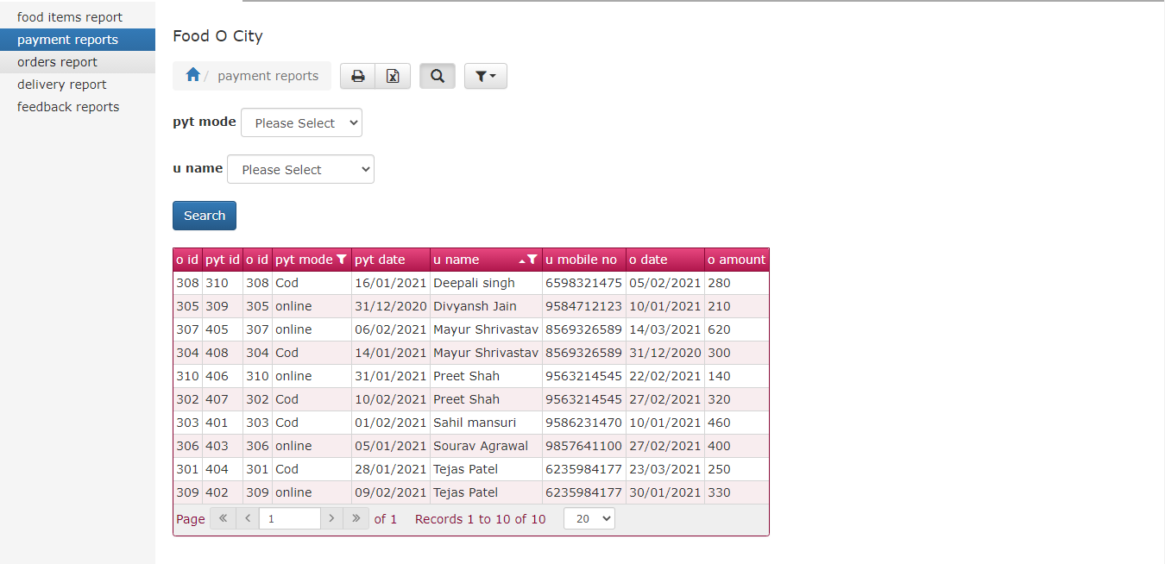

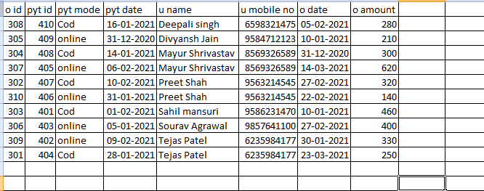

This Screenshot shows only payments made using a specific mode

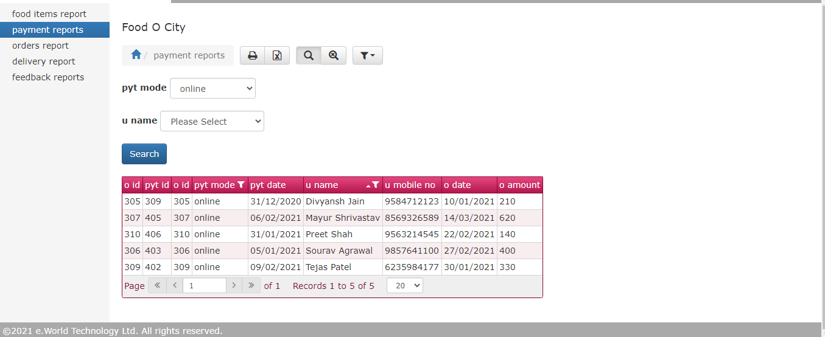

**SR. NO. 2 REPORT LAYOUTS**

**2.2 Report For Delivery**

**Description:**

This report fetches data from various tables such as Delivery Table, Order Master Table, User Type table and User Table. This report can also show data between two specific dates and it can also represent data for a specific user.

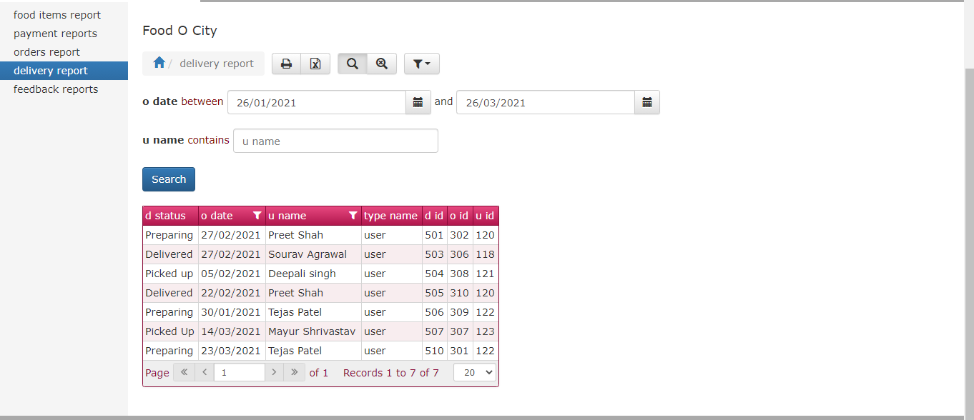

**SR. NO. 2 REPORT LAYOUTS**

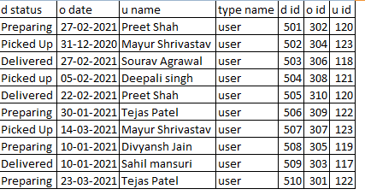

This screenshot shows data from the delivery report based on a particular user.

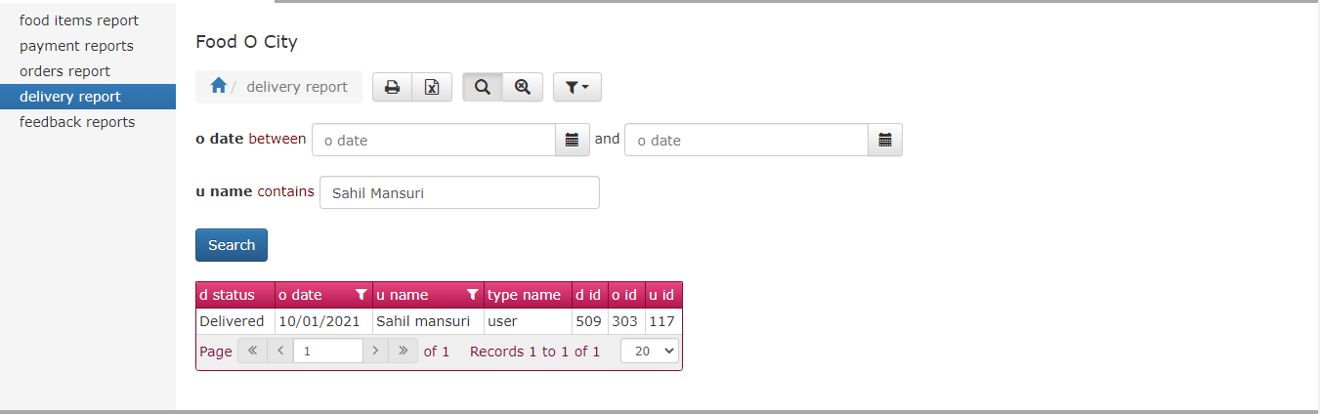

**SR. NO. 2 REPORT LAYOUTS**

**2.3 Report For Feedback**

**Description:**

This report produces information to the stakeholders regarding the feedbacks received. It fetches data from Feedback Table, and User table. Alternatively, you can also filter out results in this report based on a specific user’s name, or on the basis of a feedback’s date.

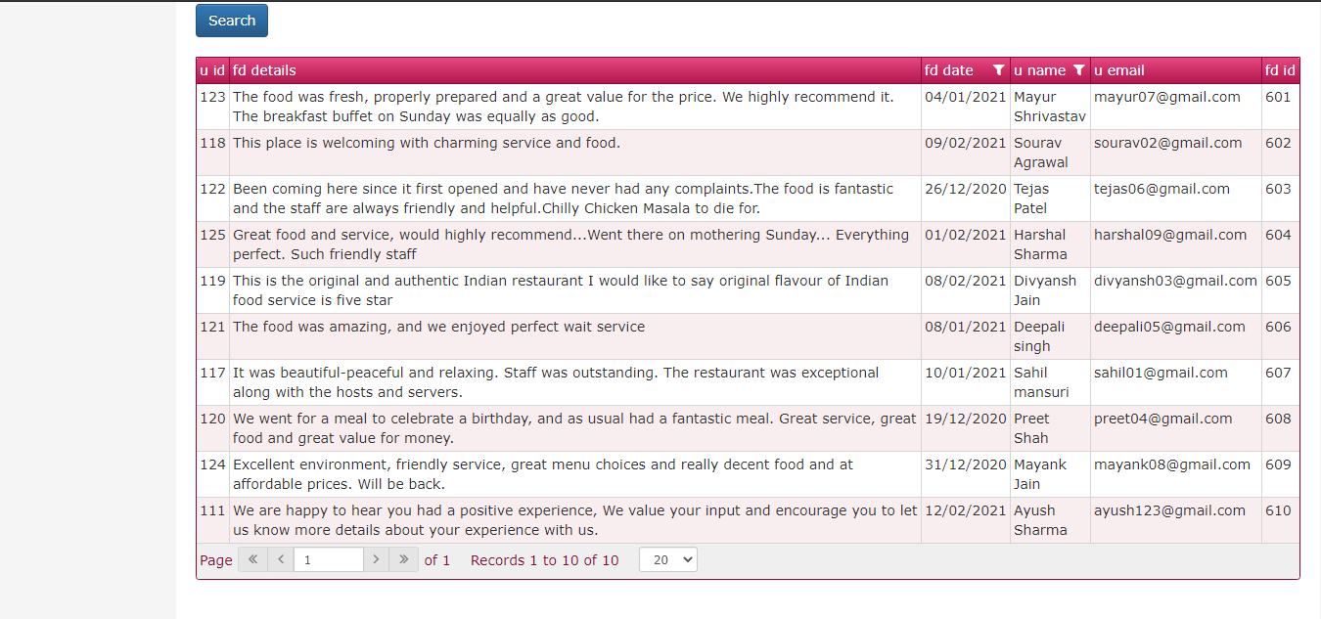

**SR. NO. 2 REPORT LAYOUTS**

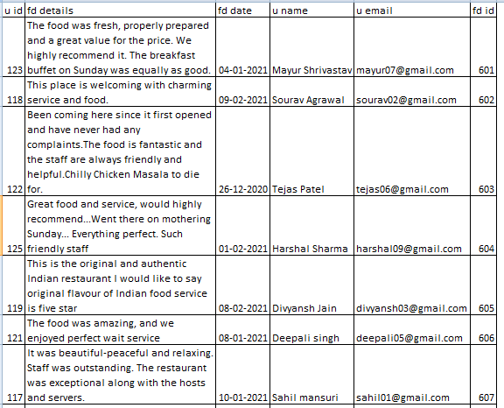

This screenshot shows report filtered on the basis of user’s name

**SR. NO. 2 REPORT LAYOUTS**

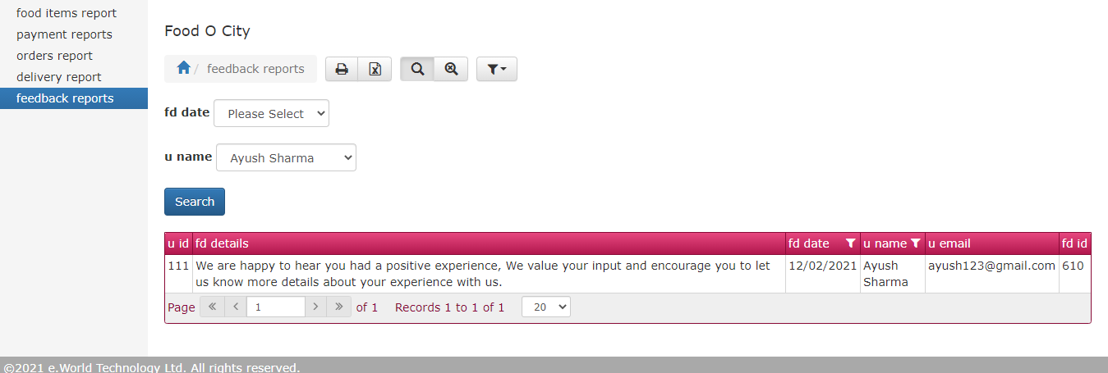

**SR. NO. 2 REPORT LAYOUTS**

**2.4. Report For Food Items**

**Description:**

This report shows data regarding the food items in the system, and to which categories do they belong. Moreover, this report can also be filtered on the basis of a specific category name.

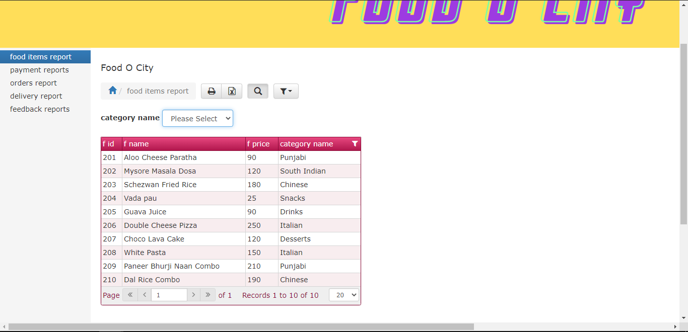

**SR. NO. 2 REPORT LAYOUTS**

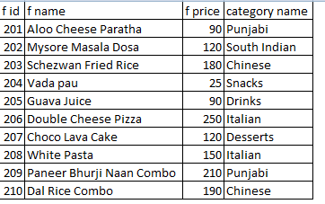

This Screenshot represents data from the food items report filtered according to a specific category.

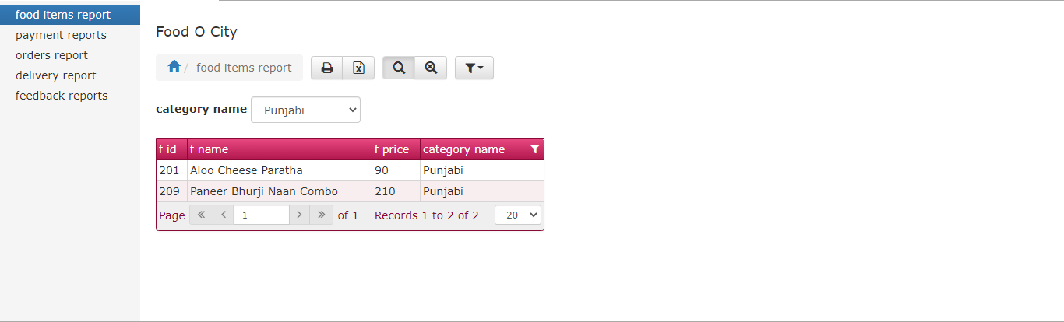

**SR. NO. 2 REPORT LAYOUTS**

* 1. **Report For Orders**

**Description:**

This report fetches data from multiple tables like User Table, Order Master Table, Food Item Table, and Payment Table. This report.

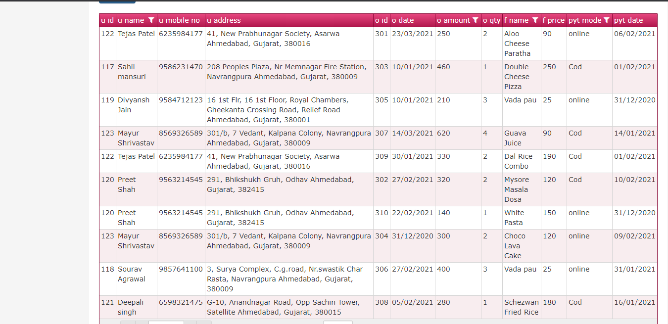

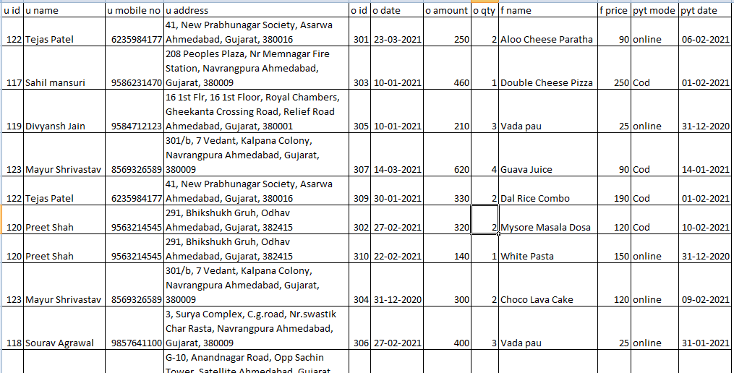

**SR.NO. 3 CONCLUSION**

We tried our best of develop this ONLINE FOOD ORDERING SYSTEM. We have tried to develop this website so that the users can order food online from any restaurant they like, in a safe and secure way.

A Restaurant can manage all his food details, order details, payment details and delivery details using our website. It can add, update or delete the food items. Our website reduces the tedious work of the restaurant by allowing it to manage its services online.

A User can view and order different food items from their favorite restaurant. User can also manage his cart. If any doubt, he can simply get in touch with us by using the contacts we provided. User can also give a feedback.

We have tried to build our website in such a way, so that both user and the restaurant can use it without any difficulty.

We did like to thank our principal **Fr. Johnson,** our internal guide **Mrs. Manali Brahmbhatt** and our external guide **Jugal Prajapati** for helping us throughout this project.

**SR.NO.4 BIBLIOGRAPHY**

The following resources were used during the execution of our project.

<https://www.djangoproject.com/start/>

<https://www.tutorialspoint.com/django/index.htm>

<https://www.geeksforgeeks.org/django-tutorial/>

<https://realpython.com/tutorials/django/>

<https://www.freepik.com>

<https://fonts.google.com/>